Sine Rule, Cosine Rule and Area Rule - basics
Name : | Class : | Date :

Mark : | /6 | %

1) Find the value of $x$ in the triangle below, giving your answer to 3 significant figures.  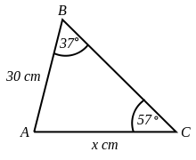 | [1]
2) Find $x$ in the triangle below, giving your answer to 3 significant figures.  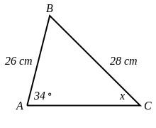 | [1]
3) Find $x$ in the triangle below, giving your answer to 3 significant figures.  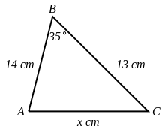 | [1]
4) Find the value of $x$ in the triangle below, giving your answer to 3 significant figures.  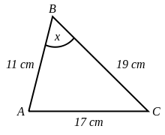 | [1]
5) The area of triangle ABC is 120 cm². Find the length of $x$, giving your answer to 3 significant figures.  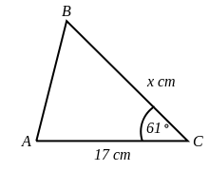 | [1]
6) The area of triangle ABC is 110 $cm^{2}$. Find the size of angle $x$, giving your answer to 3 significant figures.  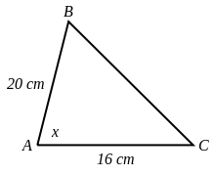 | [1]
Solutions for the assessment Sine Rule, Cosine Rule and Area Rule - basics
1) $x$ = 21.5 cm | 2) $x$ = 31.3 °
3) $x$ = 8.17 cm | 4) $x$ = 62.5 °
5) $x$ = 16.1 cm | 6) $x$ = 43.4 °

