Trigonometry - finding sides and angles
Name : | Class : | Date :

Mark : | /15 | %

1) Identify which sides are the hypotenuse, adjacent and opposite to the given angle ACB  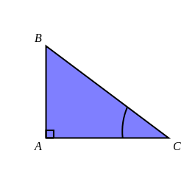 | [1]
2) Express the tangent of angle ACB as a ratio of the sides of triangle ABC  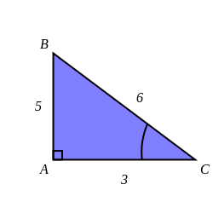 | [1]
3) Find $x$ in the triangle below, giving your answer to 3 significant figures.  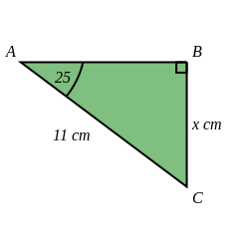 | [1]
4) Find $x$ in the triangle below, giving your answer to 3 significant figures  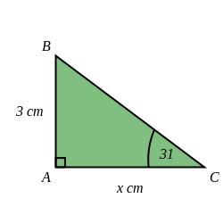 | [1]
5) Find angle $x$ in the triangle below, giving your answer to 1 decimal place.  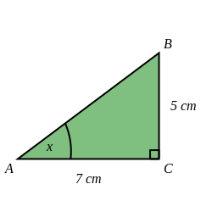 | [1]
6) Find $x$ in the triangle below, giving your answer to 3 significant figures  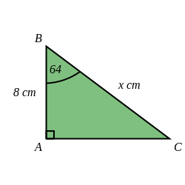 | [1]
7) Find $x$ in the triangle below, giving your answer to 3 significant figures  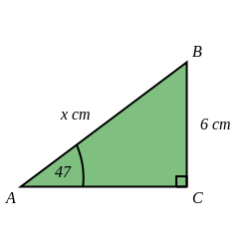 | [1]
8) Find $x$ in the triangle below, giving your answer to 3 significant figures.  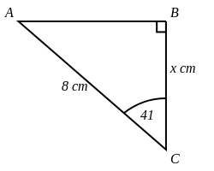 | [1]
9) Find angle $x$ in the triangle below, giving your answer to 1 decimal place.  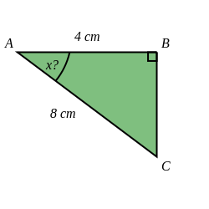 | [1]
10) Find $x$ in the triangle below, giving your answer to 3 significant figures.  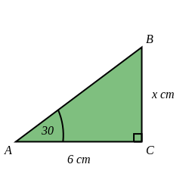 | [1]
11) Find angle $x$ in the triangle below, giving your answer to 1 decimal place.  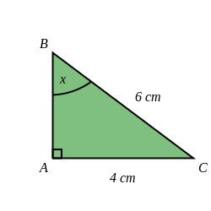 | [1]
12) A safe angle for a ladder is about 75 ° from the ground.  If you have a 4.4 metre ladder, how far from a wall should you place the base of the ladder?  Give your answer to 3 significant figures. | [1]
13) A safe angle for a ladder is about 75 ° from the ground.  If you have a 4 metre ladder, how high can it reach up a wall?  Round your answer to 3 significant figures. | [1]
14) Rebecca is looking up at a balloon. The direct distance from Rebecca to the balloon is 13 km.  The horizontal distance from Rebecca to the balloon is 10 km.  Calculate the angle of elevation from Rebecca to the balloon, giving your answer to 1 decimal place. | [1]
15) The angle of elevation from Austin to a balloon is 29 °.  The horizontal distance from Austin to the balloon is 7 km.  Calculate the direct distance from Austin to the balloon, giving your answer to 3 significant figures. | [1]
Solutions for the assessment Trigonometry - finding sides and angles
1) Hypotenuse is BC, Adjacent is AC, Opposite is AB | 2) tangent of angle ACB = $\frac{o}{a}$ = $\frac{5}{3}$
3) $x$ = 4.65 cm | 4) $x$ = 4.99 cm
5) $x$ = 35.5 ° | 6) $x$ = 18.2 cm
7) $x$ = 8.20 cm | 8) $x$ = 6.04 cm
9) $x$ = 60 ° | 10) $x$ = 3.46 cm
11) $x$ = 41.8 ° | 12) Distance = 1.14 m
13) Height = 3.86 m | 14) Angle of elevation = 39.7 °
15) Distance = 8.00 km

