Trigonometry - finding sides and angles
Name : | Class : | Date :

Mark : | /15 | %

1) Identify which sides are the hypotenuse, adjacent and opposite to the given angle ABC  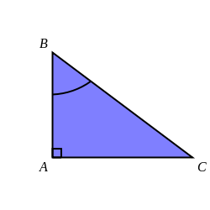 | [1]
2) Express the cosine of angle ACB as a ratio of the sides of triangle ABC  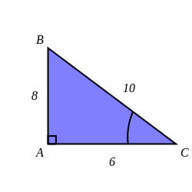 | [1]
3) Find $x$ in the triangle below, giving your answer to 3 significant figures.  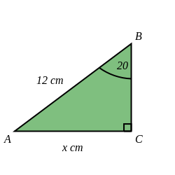 | [1]
4) Find $x$ in the triangle below, giving your answer to 3 significant figures  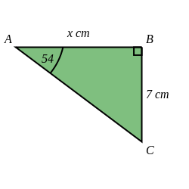 | [1]
5) Find angle $x$ in the triangle below, giving your answer to 1 decimal place.  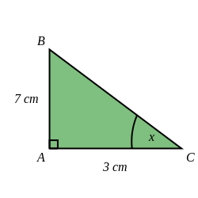 | [1]
6) Find $x$ in the triangle below, giving your answer to 3 significant figures  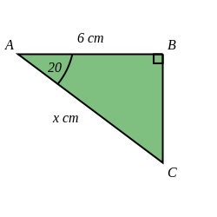 | [1]
7) Find $x$ in the triangle below, giving your answer to 3 significant figures  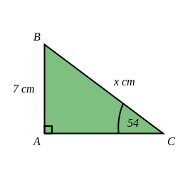 | [1]
8) Find $x$ in the triangle below, giving your answer to 3 significant figures.  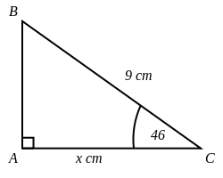 | [1]
9) Find angle $x$ in the triangle below, giving your answer to 1 decimal place.  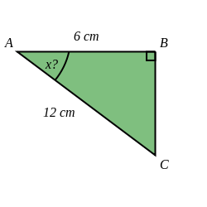 | [1]
10) Find $x$ in the triangle below, giving your answer to 3 significant figures.  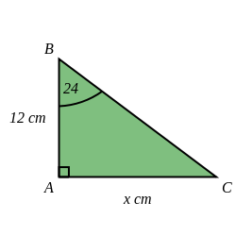 | [1]
11) Find angle $x$ in the triangle below, giving your answer to 1 decimal place.  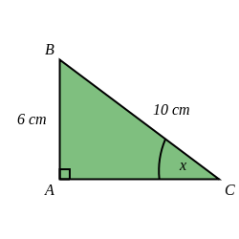 | [1]
12) A safe angle for a ladder is about 75 ° from the ground.  If you have a 7.8 metre ladder, how far from a wall should you place the base of the ladder?  Give your answer to 3 significant figures. | [1]
13) A safe angle for a ladder is about 75 ° from the ground.  If you have a 4.5 metre ladder, how high can it reach up a wall?  Round your answer to 3 significant figures. | [1]
14) Luke is looking up at a spaceship. The direct distance from Luke to the spaceship is 13 km.  The vertical distance from Luke to the spaceship is 9 km.  Calculate the angle of elevation from Luke to the spaceship, giving your answer to 1 decimal place. | [1]
15) The angle of elevation from Austin to a balloon is 44 °.  The horizontal distance from Austin to the balloon is 4 km.  Calculate the direct distance from Austin to the balloon, giving your answer to 3 significant figures. | [1]
Solutions for the assessment Trigonometry - finding sides and angles
1) Hypotenuse is BC, Adjacent is AB, Opposite is AC | 2) cosine of angle ACB = $\frac{a}{h}$ = $\frac{6}{10}$
3) $x$ = 4.10 cm | 4) $x$ = 5.09 cm
5) $x$ = 66.8 ° | 6) $x$ = 6.39 cm
7) $x$ = 8.65 cm | 8) $x$ = 6.25 cm
9) $x$ = 60 ° | 10) $x$ = 5.34 cm
11) $x$ = 36.9 ° | 12) Distance = 2.02 m
13) Height = 4.35 m | 14) Angle of elevation = 43.8 °
15) Distance = 5.56 km

