Trigonometry - finding sides and angles
Name : | Class : | Date :

Mark : | /15 | %

1) Identify which sides are the hypotenuse, adjacent and opposite to the given angle ABC  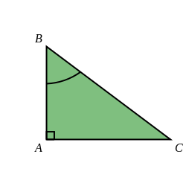 | [1]
2) Express the sine of angle ACB as a ratio of the sides of triangle ABC  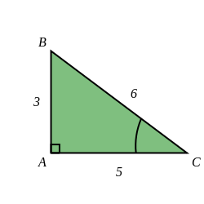 | [1]
3) Find $x$ in the triangle below, giving your answer to 3 significant figures.  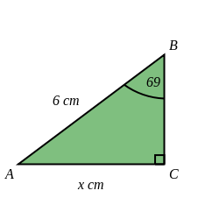 | [1]
4) Find $x$ in the triangle below, giving your answer to 3 significant figures  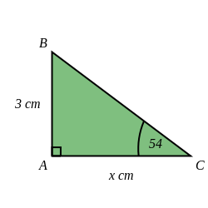 | [1]
5) Find angle $x$ in the triangle below, giving your answer to 1 decimal place.  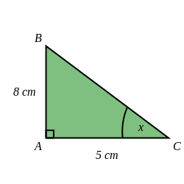 | [1]
6) Find $x$ in the triangle below, giving your answer to 3 significant figures  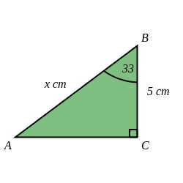 | [1]
7) Find $x$ in the triangle below, giving your answer to 3 significant figures  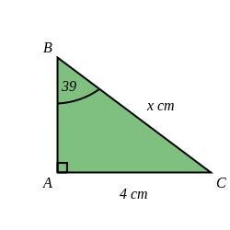 | [1]
8) Find $x$ in the triangle below, giving your answer to 3 significant figures.  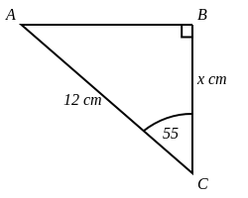 | [1]
9) Find angle $x$ in the triangle below, giving your answer to 1 decimal place.  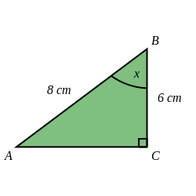 | [1]
10) Find $x$ in the triangle below, giving your answer to 3 significant figures.  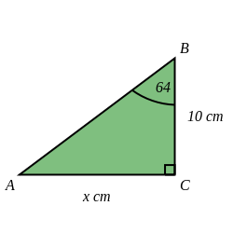 | [1]
11) Find angle $x$ in the triangle below, giving your answer to 1 decimal place.  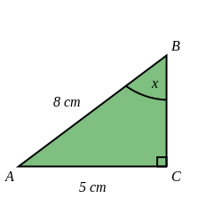 | [1]
12) A safe angle for a ladder is about 75 ° from the ground.  If you have a 3.8 metre ladder, how far from a wall should you place the base of the ladder?  Give your answer to 3 significant figures. | [1]
13) A safe angle for a ladder is about 75 ° from the ground.  If you have a 3.5 metre ladder, how high can it reach up a wall?  Round your answer to 3 significant figures. | [1]
14) Holly is looking up at a helicopter. The direct distance from Holly to the helicopter is 16 km.  The vertical distance from Holly to the helicopter is 11 km.  Calculate the angle of elevation from Holly to the helicopter, giving your answer to 1 decimal place. | [1]
15) The angle of elevation from Rose to a helicopter is 46 °.  The horizontal distance from Rose to the helicopter is 4 km.  Calculate the direct distance from Rose to the helicopter, giving your answer to 3 significant figures. | [1]
Solutions for the assessment Trigonometry - finding sides and angles
1) Hypotenuse is BC, Adjacent is AB, Opposite is AC | 2) sine of angle ACB = $\frac{o}{h}$ = $\frac{3}{6}$
3) $x$ = 5.60 cm | 4) $x$ = 2.18 cm
5) $x$ = 58 ° | 6) $x$ = 5.96 cm
7) $x$ = 6.36 cm | 8) $x$ = 6.88 cm
9) $x$ = 41.4 ° | 10) $x$ = 20.5 cm
11) $x$ = 38.7 ° | 12) Distance = 0.984 m
13) Height = 3.38 m | 14) Angle of elevation = 43.4 °
15) Distance = 5.76 km

