3D Pythagoras
Name : | Class : | Date :

Mark : | /7 | %

1) Find the length of BD in the shape pictured below, giving your answer to 3 significant figures.  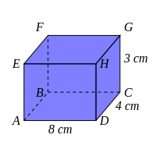 | [1]
2) Find the length of AC in the shape pictured below, giving your answer to 3 significant figures.  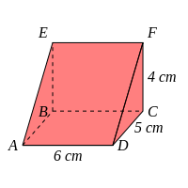 | [1]
3) Find the length of AC in the shape pictured below, giving your answer to 3 significant figures.  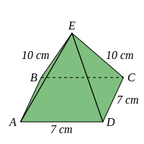 | [1]
4) Find the length of BH in the shape pictured below, giving your answer to 3 significant figures.  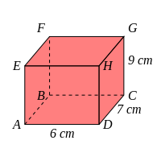 | [1]
5) Find the length of DE in the shape pictured below, giving your answer to 3 significant figures.  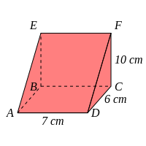 | [1]
6) Find the length of OD in the shape pictured below where O is the centre of the base ABCD.  Give your answer to 3 significant figures.  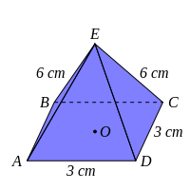 | [1]
7) Find the vertical height, OE, of the pyramid pictured below (where O is the centre of the base ABCD).  Give your answer to 3 significant figures.  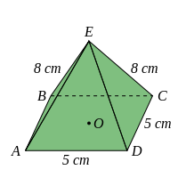 | [1]
Solutions for the assessment 3D Pythagoras
1) BD = 8.94 cm | 2) AC = 7.81 cm
3) AC = 9.90 cm | 4) BH = 12.9 cm
5) DE = 13.6 cm | 6) OD = 2.12 cm
7) Height = 7.18 cm

