2D Pythagoras
Name : | Class : | Date :

Mark : | /12 | %

1) Find the missing length in the triangle pictured below  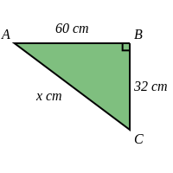 | [1]
2) Find the missing length in the triangle pictured below  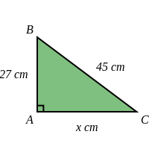 | [1]
3) A right-angled triangle has two shorts side of length 99 cm and 20 cm. Find the length of the hypotenuse. | [1]
4) A right-angled triangle has a hypotenuse of length 90 cm and one short side of length 72 cm. Find the length of the other short side. | [1]
5) Find the missing length in the triangle pictured below, giving your answer to 3 significant figures  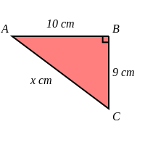 | [1]
6) Find the missing length in the triangle pictured below, giving your answer to 3 significant figures  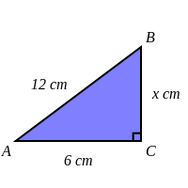 | [1]
7) A right-angled triangle has short sides of length 6 cm and 5 cm. Find the length of the hypotenuse, giving your answer to 3 significant figures. | [1]
8) A right-angled triangle has a hypotenuse of length 18 cm and a short side of length 5 cm. Find the length of the other short side, giving your answer to 3 significant figures. | [1]
9) The base of a ladder is 6 metres from a wall. The height of the wall is 8 metres.  What is the minimum height the ladder must be to reach the top of the wall? (give your answer to 3 significant figures) | [1]
10) Find the distance between the coordinates $(-4,-4)$ and $(0,-1)$, giving your answer to 3 significant figures | [1]
11) Find the length of the line segment shown below, giving your answer to 3 significant figures  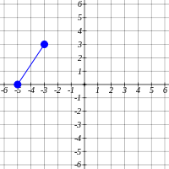 | [1]
12) The diagram shows a field with length 300 metres and width 180 metres.  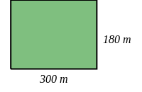  Find the diagonal distance across the field.  Give your answer to the nearest metre. | [1]
Solutions for the assessment 2D Pythagoras
1) $x$ = 68 cm | 2) $x$ = 36 cm
3) $x$ = 101 cm | 4) $x$ = 54 cm
5) $x$ = 13.5 cm | 6) $x$ = 10.4 cm
7) $x$ = 7.81 cm | 8) $x$ = 17.3 cm
9) Height = 10 cm | 10)  Distance = $\sqrt{4^{2}+3^{2}}$  Distance = $\sqrt{25}$  Distance = 5`
11)  Length = $\sqrt{2^{2}+3^{2}}$  Length = $\sqrt{13}$  Length = 3.61` | 12) Diagonal distance = 350 m

