Construction and Scale Drawings
Name : | Class : | Date :

Mark : | /12 | %

1) Construct an angle of 60 ° | [1]
2) Construct the perpendicular bisector of the line AB below  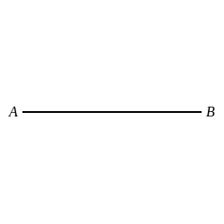 | [1]
3) Construct the angle bisector of angle ABC below  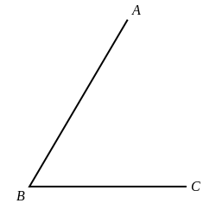 | [1]
4) Construct a perpendicular to AB at the point C  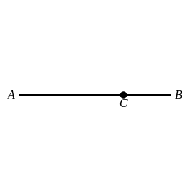 | [1]
5) Construct a perpendicular from point C to AB  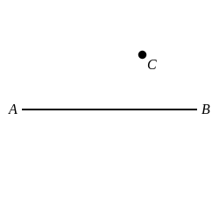 | [1]
6) Construct triangle ABC with sides of length 6.1 cm as shown in the diagram below (not drawn to scale).  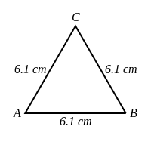  Measure the perpendicular height of your construction in centimetres (to the nearest mm). | [1]
7) Construct a triangle ABC with a base length AB = 7.6 cm and sides AC = 6.3 cm and BC = 6.3 cm as shown in the diagram below.  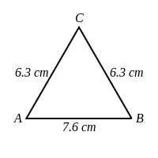  Measure the perpendicular height of your construction from the base AB in centimetres (to the nearest mm). | [1]
8) Construct a triangle ABC with a base length AB = 8.5 cm and sides AC = 6.6 cm and BC = 5.1 cm as shown in the diagram below.  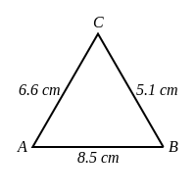  Measure the perpendicular height of your construction from the base AB in centimetres (to the nearest mm). | [1]
9) Construct triangle ABC where base AB = 8.3 cm, AC = 7.8 cm and angle BAC = 49 ° as shown in the diagram below.  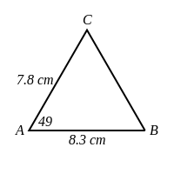  a) Measure the length BC of your construction, giving your answer in centimetres (to the nearest mm).  b) Measure angle ABC on your construction, giving your answer to the nearest degree. | [1]
10) Construct a triangle ABC with a base length AB = 8.1 cm and sides AC = 7 cm and BC = 5.7 cm.  Measure the perpendicular height from the base AB in centimetres (to the nearest mm). | [1]
11) The diagram shows a field with length 240 metres and width 180 metres.  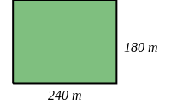  Use a scale of 1 cm to 30 m to make an accurate scale drawing of the field.  Find the diagonal distance across the field.  Give your answer to the nearest metre. | [1]
12) The diagram shows a sketch of a triangle ABC with base length AB = 27 m and sides AC = 18 m and BC = 15 m.  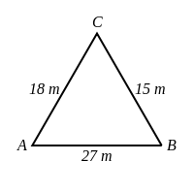  Use a scale of 1 cm to 3 m to make an accurate scale drawing of the triangle.  Find the perpendicular height from the base AB of the triangle by measuring your construction.  Give your answer to the nearest metre. | [1]
Solutions for the assessment Construction and Scale Drawings
1)
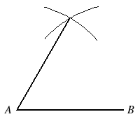

2)
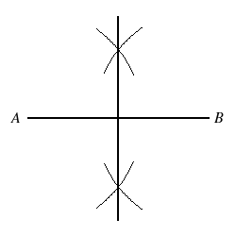

3)
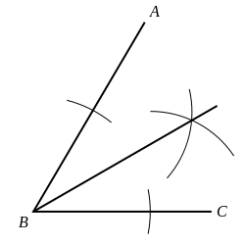

4)
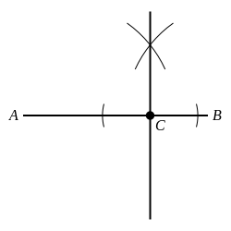

5)
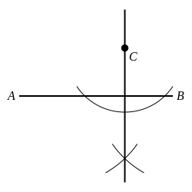

6) Perpendicular height = 5.3 cm | 7) Perpendicular height = 5 cm
8) Perpendicular height = 4 cm | 9) a) BC = 6.7 cm, b) angle ABC = 62 °
10) Perpendicular height = 4.8 cm | 11) Diagonal distance = 300 m
12) Perpendicular height = 9 m

