Surface Area and Volume of 3D shapes - non prism
Name : | Class : | Date :

Mark : | /9 | %

1) Find the volume and surface area of the cube  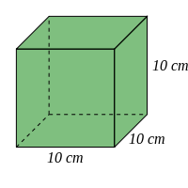 | [1]
2) Find the volume and surface area of the cuboid  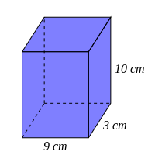 | [1]
3) Find the volume and surface area of the cylinder, rounding your answers to 3 significant figures  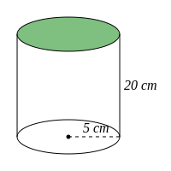 | [1]
4) Find the volume and surface area of the sphere, rounding your answers to 3 significant figures  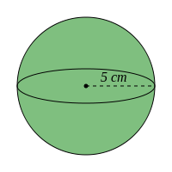 | [1]
5) Find the volume and surface area of the solid cone, rounding your answers to 3 significant figures.  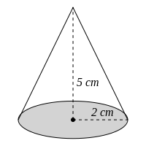 | [1]
6) Find the volume of a cube, given that its surface area is 600 $cm^{2}$ | [1]
7) Find the surface area of a cube, given that its volume is 729 $cm^{3}$ | [1]
8) Find the volume of a sphere, given that its surface area is 530 $cm^{2}$, rounding your answer to 3 significant figures | [1]
9) Find the surface area of a sphere, given that its volume is 110 $cm^{3}$, rounding your answer to 3 significant figures | [1]
Solutions for the assessment Surface Area and Volume of 3D shapes - non prism
1) Volume = 1000 $cm^{3}$, Surface area = 600 $cm^{2}$ | 2) Volume = 270 $cm^{3}$, Surface area = 294 $cm^{2}$
3) Volume = 1570 $cm^{3}$, Surface area = 785 $cm^{2}$ | 4) Volume = 524 $cm^{3}$, Surface area = 314 $cm^{2}$
5) Volume = 20.9 $cm^{3}$, Surface area = 46.4 $cm^{2}$ | 6) Volume = 1000 $cm^{3}$
7) Surface area = 486 $cm^{2}$ | 8) Volume = 1150 $cm^{3}$
9) Surface area = 111 $cm^{2}$

