Volume of 3D shapes - basics
Name : | Class : | Date :

Mark : | /10 | %

1) The solid shape shown below is made from cubes of side one centimetre.  Find the volume of the solid.  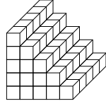 | [1]
2) Find the volume of the cuboid, given that the area of the base is 32 $cm^{2}$ and the height is 3 cm  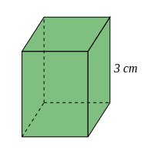 | [1]
3) Find the volume of the cuboid  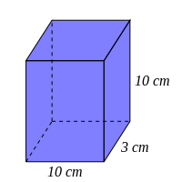 | [1]
4) A cube has a length of 35 cm. Find its volume. | [1]
5) Find the missing dimension, given that the volume of the cuboid is 160 $cm^{3}$  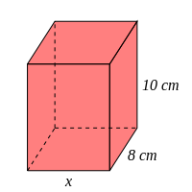 | [1]
6) Find its length, given that the volume of a cube is 19683 $cm^{3}$ | [1]
7) Find the volume of the triangular prism, given that the cross-sectional area is 3 $cm^{2}$ and the length is 12 cm  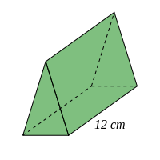 | [1]
8) Find the volume of the triangular prism  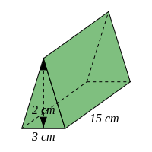 | [1]
9) Find the volume of the cylinder, rounding your answer to 3 significant figures  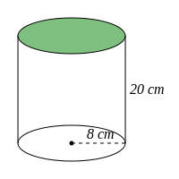 | [1]
10) Find the volume of the trapezoidal prism  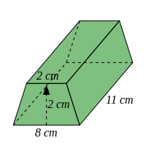 | [1]
Solutions for the assessment Volume of 3D shapes - basics
1) Volume = 75 $cm^{3}$ | 2) Volume = 96 $cm^{3}$
3) Volume = 300 $cm^{3}$ | 4) Volume = 42875 $cm^{3}$
5) $x$ = 2 cm | 6) Length = 27 cm
7) Volume = 36 $cm^{3}$ | 8) Volume = 45 $cm^{3}$
9) 4020 $cm^{3}$ | 10) Volume = 110 $cm^{3}$

