Volume of 3D shapes - basics
Name : | Class : | Date :

Mark : | /10 | %

1) The solid shape shown below is made from cubes of side one centimetre.  Find the volume of the solid.  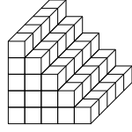 | [1]
2) Find the volume of the cuboid, given that the area of the base is 20 $cm^{2}$ and the height is 7 cm  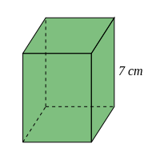 | [1]
3) Find the volume of the cuboid  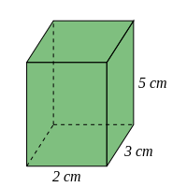 | [1]
4) A cube has a length of 27 cm. Find its volume. | [1]
5) Find the missing dimension, given that the volume of the cuboid is 180 $cm^{3}$  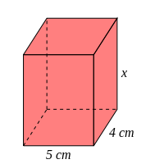 | [1]
6) Find its length, given that the volume of a cube is 54872 $cm^{3}$ | [1]
7) Find the volume of the triangular prism, given that the cross-sectional area is 4 $cm^{2}$ and the length is 13 cm  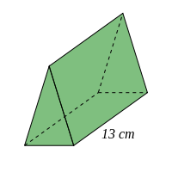 | [1]
8) Find the volume of the triangular prism  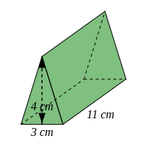 | [1]
9) Find the volume of the cylinder, rounding your answer to 3 significant figures  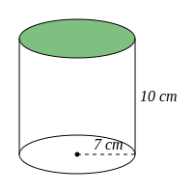 | [1]
10) Find the volume of the trapezoidal prism  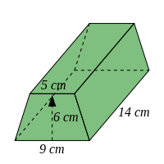 | [1]
Solutions for the assessment Volume of 3D shapes - basics
1) Volume = 75 $cm^{3}$ | 2) Volume = 140 $cm^{3}$
3) Volume = 30 $cm^{3}$ | 4) Volume = 19683 $cm^{3}$
5) $x$ = 9 cm | 6) Length = 38 cm
7) Volume = 52 $cm^{3}$ | 8) Volume = 66 $cm^{3}$
9) 1540 $cm^{3}$ | 10) Volume = 588 $cm^{3}$

