Surface Area of 3D Shapes - Prisms
Name : | Class : | Date :

Mark : | /9 | %

1) Find the surface area of the cube  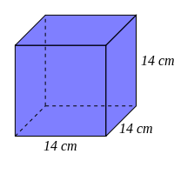 | [1]
2) Find the surface area of the cuboid  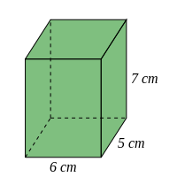 | [1]
3) Find the surface area of the triangular prism  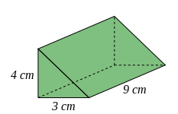 | [1]
4) Find the surface area of the cylinder, rounding your answer to 3 significant figures  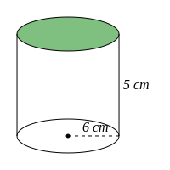 | [1]
5) A cube has sides of length 8 cm. Find its surface area. | [1]
6) A cube has a surface area of 6144 $cm^{2}$. Find its length. | [1]
7) A cuboid has length, width and height of 10 cm, 9 cm and 10 cm, respectively. Find its surface area. | [1]
8) A triangular prism has a length of 12 cm. Its cross-section is an equilateral triangle which has sides of length 2 cm. Find the surface area of the triangular prism, rounding your answer to 3 significant figures. | [1]
9) A solid cylinder has a radius of 4 cm and a length 5 cm. Find its surface area, rounding your answer to 3 significant figures | [1]
Solutions for the assessment Surface Area of 3D Shapes - Prisms
1) Surface area = 1176 $cm^{2}$ | 2) Surface area = 214 $cm^{2}$
3) Surface area = 120 $cm^{2}$ | 4) Surface area = 415 $cm^{2}$
5) Surface area = 384 $cm^{2}$ | 6) Length = 32 cm
7) Surface area = 560 $cm^{2}$ | 8) Surface area = 75.5 $cm^{2}$
9) Surface area = 226 $cm^{2}$

