Circles, Perimeters and Sectors
Name : | Class : | Date :

Mark : | /14 | %

1) Find the area of the semicircle, rounding your answer to 3 significant figures  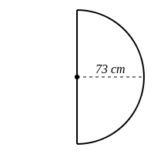 | [1]
2) Find the area of the three-quarter circle, rounding your answer to 3 significant figures  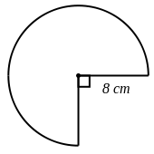 | [1]
3) Find the area of the sector, rounding your answer to 3 significant figures  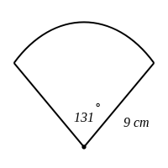 | [1]
4) Find the arc length of the semicircle, rounding your answer to 3 significant figures  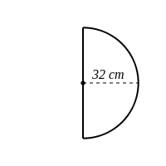 | [1]
5) Find the arc length of the shape below, rounding your answer to 3 significant figures  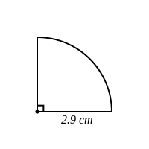 | [1]
6) Find the arc length of the sector shown below, rounding your answer to 3 significant figures  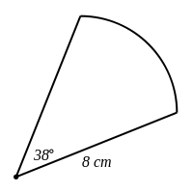 | [1]
7) Find the perimeter of the semicircle, rounding your answer to 3 significant figures  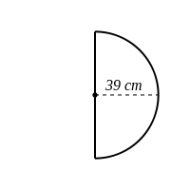 | [1]
8) Find the perimeter of the semicircle, rounding your answer to 3 significant figures  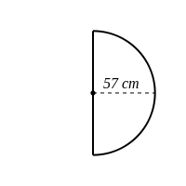 | [1]
9) Find the perimeter of the three-quarter circle, rounding your answer to 3 significant figures  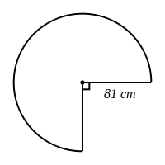 | [1]
10) Find the perimeter of the shape below, rounding your answer to 3 significant figures  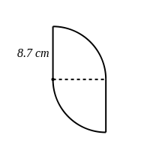 | [1]
11) Find the area of the circle pictured below, rounding your answer to 3 significant figures  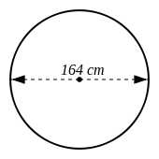 | [1]
12) Find the radius of a circle which has an area of 27 $cm^{2}$ | [1]
13) Find the circumference of the circle pictured below, rounding your answer to 3 significant figures  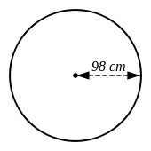 | [1]
14) Find the radius of a circle, where the circumference is:  30 cm | [1]
Solutions for the assessment Circles, Perimeters and Sectors
1) Area = 8370 $cm^{2}$ | 2) Area = 151 $cm^{2}$
3) Area = 92.6 $cm^{2}$ | 4) Arc length = 101 cm
5) Arc length = 4.56 cm | 6) Arc length = 5.31 cm
7) Perimeter = 201 cm | 8) Perimeter = 293 cm
9) Perimeter = 544 cm | 10) Perimeter = 44.7 cm
11) Area = 21100 $cm^{2}$ | 12) Radius = 2.93 cm
13) Circumference = 616 cm | 14) Radius = 4.77 cm

