Area of a Circle
Name : | Class : | Date :

Mark : | /7 | %

1) Estimate the area of the circle by counting unit squares  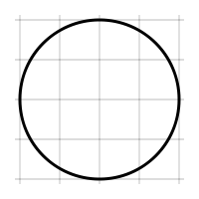 | [1]
2) Find the area of the circle pictured below, rounding your answer to 3 significant figures  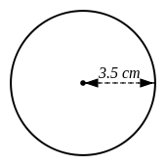 | [1]
3) Find the area of the circle pictured below, rounding your answer to 3 significant figures  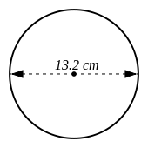 | [1]
4) Find the radius of a circle which has an area of 79 $cm^{2}$ | [1]
5) Find the diameter of a circle which has an area of 7.8 $cm^{2}$ | [1]
6) The radius of a circle is 48 cm. Find the area of the circle, rounding your answer to 3 significant figures. | [1]
7) The diameter of a circle is 10.6 cm. Find the area of the circle, rounding your answer to 3 significant figures. | [1]
Solutions for the assessment Area of a Circle
1) Area = 13 $cm^{2}$ | 2) Area = 38.5 $cm^{2}$
3) Area = 137 $cm^{2}$ | 4) Radius = 5.01 cm
5) Diameter = 3.15 cm | 6) Area = 7240 $cm^{2}$
7) Area = 88.2 $cm^{2}$

