Circumference of a Circle
Name : | Class : | Date :

Mark : | /7 | %

1) Name the labelled parts of the circle below.  Choose from the following words: circumference, centre, radius, diameter  1. ..................  2. ..................  3. ..................  4. .................. | [1]
2) Find the circumference of the circle pictured below, rounding your answer to 3 significant figures  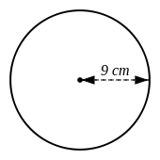 | [1]
3) A circle has a radius of 8.7 cm. Find the circumference of the circle, rounding your answer to 3 significant figures. | [1]
4) Find the circumference of the circle pictured below, rounding your answer to 3 significant figures  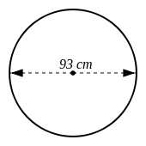 | [1]
5) The diameter of a circle is 2 cm. Find the circumference of the circle, rounding your answer to 3 significant figures. | [1]
6) Find the radius of a circle, where the circumference is:  26 cm | [1]
7) Find the diameter of a circle, where the circumference is:  6.1 cm | [1]
Solutions for the assessment Circumference of a Circle
1) 1 = centre, 2 = diameter, 3 = radius, 4 = circumference | 2) Circumference = 56.5 cm
3) Circumference = 54.7 cm | 4) Circumference = 292 cm
5) Circumference = 6.28 cm | 6) Radius = 4.14 cm
7) Diameter = 1.94 cm

