Areas, Perimeters and Compound Shapes
Name : | Class : | Date :

Mark : | /15 | %

1) Find the area and perimeter of the shape. Each square on the grid is 1 cm². | [1]
2) Find the area and perimeter of the square.  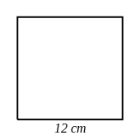 | [1]
3) Find the area and perimeter of the rectangle.  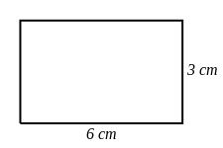 | [1]
4) Find the area and perimeter of the triangle.  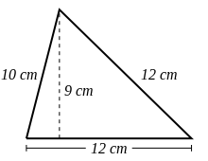 | [1]
5) Find the area and perimeter of the parallelogram.  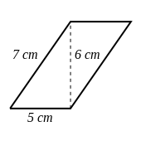 | [1]
6) The length of a rectangle is 11 cm and its width is 10 cm.  Find the area and perimeter of the rectangle. | [1]
7) Here is a figure made of two rectangles.  (a) What is the perimeter of the figure?  (b) What is the area of the figure?  (c) How much greater is the area of the figure than its perimeter? | [1]
8) Here is a figure made of two rectangles.  (a) What is the perimeter of the figure?  (b) What is the area of the figure?  (c) What is the difference between the area and the perimeter of the figure? | [1]
9) Find the area of the kite  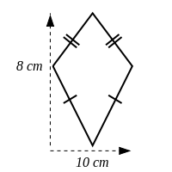 | [1]
10) Find the area of the trapezium  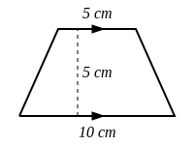 | [1]
11) Find the area of the shape below.  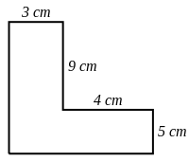 | [1]
12) Find the area of the shape below.  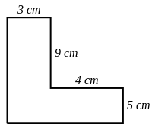 | [1]
13) Find the area of the shape below.  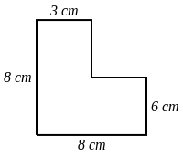 | [1]
14) Find the area of the shape below.  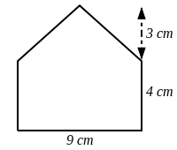 | [1]
15) Find the area of the shape below.  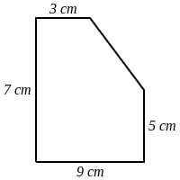 | [1]
Solutions for the assessment Areas, Perimeters and Compound Shapes
1) Area = 4 cm², Perimeter = 10 cm | 2) Area = 144cm², Perimeter = 48cm
3) Area = 18cm², Perimeter = 18cm | 4) Area = 54cm², Perimeter = 34cm
5) Area = 30cm², Perimeter = 24cm | 6) Area = 110cm², Perimeter = 42cm
7) Perimeter = 36 cm, Area = 44 cm², Difference = 8 | 8) Perimeter = 26 cm, Area = 33 cm², Difference = 7
9) Area = 40 $cm^{2}$ | 10) Area = 37.5 $cm^{2}$
11) Area = 62 cm² | 12) Area = 62 cm²
13) Area = 54 cm² | 14) Area = 49.5 cm²
15) Area = 57 cm²

