Area of triangle and parallelogram
Name : | Class : | Date :

Mark : | /8 | %

1) Match each area formula with the correct shape  1. $A=l^{2}$ A. Triangle  2. $A=lw$ B. Parallelogram  3. $A=\frac{1}{2}bh$ C. Rectangle  4. $A=bh$ D. Square | [1]
2) Find the area of the triangle.  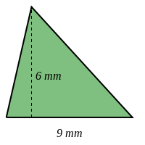 Area = ..... mm² | [1]
3) Find the area of the triangle.  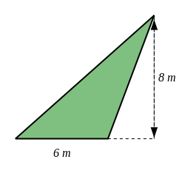 Area = ..... m² | [1]
4) Find the area of the parallelogram if the perpendicular height from the base is 5 m and the base is 9 m.  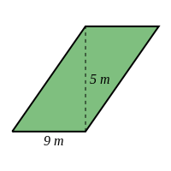Area = ..... $m^{2}$ | [1]
5) Find the area of the rhombus if the perpendicular height from the base is 7 m and the base is 12 m.  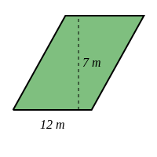Area = ..... $m^{2}$ | [1]
6) Find the area of a triangle, given that it has a base of 6 cm and a perpendicular height to the base of 6 cm.  Area = ......... cm² | [1]
7) Find the area of a parallelogram, given that it has a base of 9 cm and a height perpendicular to the base of 5 cm.  Area = ..... $cm^{2}$ | [1]
8) Find the area of the shape below.  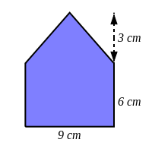 Area = ..... $cm^{2}$ | [1]
Solutions for the assessment Area of triangle and parallelogram
1) 1 D, 2 C, 3 A, 4 B | 2) Area = 27 $mm^{2}$
3) Area = 24 $m^{2}$ | 4) Area = 45 $m^{2}$
5) Area = 84 $m^{2}$ | 6) Area = 18 cm²
7) Area = 45 $cm^{2}$ | 8) Area = 67.5 $cm^{2}$

