Area of Quadrilaterals
Name : | Class : | Date :

Mark : | /10 | %

1) Find the area of the rectangle  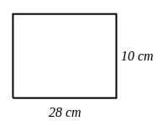 | [1]
2) Find the area of the parallelogram if the perpendicular height from the base is 7 cm  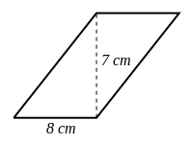 | [1]
3) Find the area of the trapezium  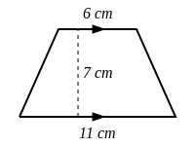 | [1]
4) Find the area of the kite  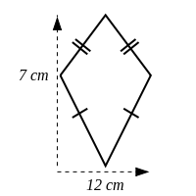 | [1]
5) Match each area formula with the correct shape  1. $A=l^{2}$ A. Rectangle  2. $A=lw$ B. Square  3. $A=\frac{1}{2}bh$ C. Circle  4. $A=πr^{2}$ D. Triangle  5. $A=bh$ E. Trapezium  6. $A=\frac{l}{2}h(a+b)$ F. Parallelogram | [1]
6) Find the missing dimension of the rectangle, given an area of 231 $cm^{2}$.  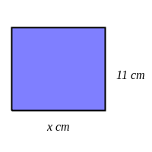 | [1]
7) Find the missing dimension of the trapezium, given an area of 35 $cm^{2}$.  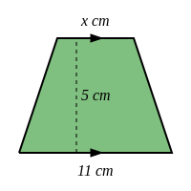 | [1]
8) Find the length $x$ of the parallelogram, given an area of 30 $cm^{2}$.  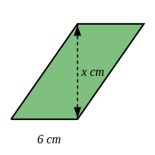 | [1]
9) Find the area of the shape below.  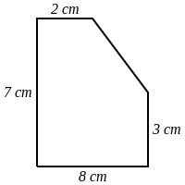 | [1]
10) Find the area of the shape below.  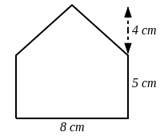 | [1]
Solutions for the assessment Area of Quadrilaterals
1) Area = 280 $cm^{2}$ | 2) Area = 56 $cm^{2}$
3) Area = 59.5 $cm^{2}$ | 4) Area = 42 $cm^{2}$
5) 1 B, 2 A, 3 D, 4 C, 5 F, 6 E | 6) $x$ = 21 cm
7) $x$ = 3 cm | 8) $x$ = 5 cm
9) Area = 44 cm² | 10) Area = 56 cm²

