Basic Areas of 2D shapes
Name : | Class : | Date :

Mark : | /7 | %

1) Complete the table with names of quadrilaterals  Shape  Name | [1]
2) Complete the table to show the properties of 4 shapes.  Shape Number of sides Number of right angles All sides equal (yes or no)  4 4 yes | [1]
3) Find the area of the rectangle  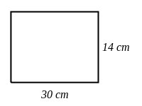 | [1]
4) Find the area of the triangle  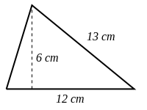 | [1]
5) Find the area of the rhombus if the perpendicular height from the base is 6 cm  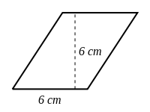 | [1]
6) Find the area of the kite  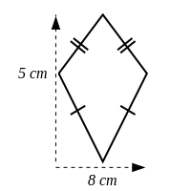 | [1]
7) Find the area of the trapezium  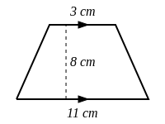 | [1]
Solutions for the assessment Basic Areas of 2D shapes
1) Parallelogram,Square,Rhombus,Kite,Rectangle,Trapezium | 2) 4, 1, no  4, 0, no  4, 0, no
3) Area = 420 $cm^{2}$ | 4) Area = 36 $cm^{2}$
5) Area = 36 $cm^{2}$ | 6) Area = 20 $cm^{2}$
7) Area = 56 $cm^{2}$

