Basic Areas of 2D shapes
Name : | Class : | Date :

Mark : | /7 | %

1) Complete the table with names of quadrilaterals  Shape  Name | [1]
2) Complete the table to show the properties of 4 shapes.  Shape Number of sides Number of right angles All sides equal (yes or no)  4 4 no | [1]
3) Find the area of the rectangle  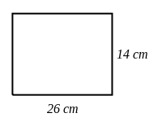 | [1]
4) Find the area of the triangle  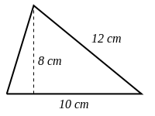 | [1]
5) Find the area of the rhombus if the perpendicular height from the base is 8 cm  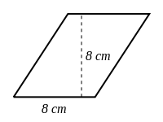 | [1]
6) Find the area of the kite  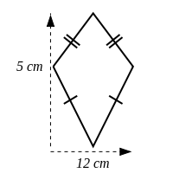 | [1]
7) Find the area of the trapezium  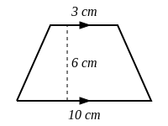 | [1]
Solutions for the assessment Basic Areas of 2D shapes
1) Trapezium,Square,Kite,Parallelogram,Rhombus,Rectangle | 2) 4, 0, no  4, 0, yes  4, 1, no
3) Area = 364 $cm^{2}$ | 4) Area = 40 $cm^{2}$
5) Area = 64 $cm^{2}$ | 6) Area = 30 $cm^{2}$
7) Area = 39 $cm^{2}$

