Area of a Triangle
Name : | Class : | Date :

Mark : | /7 | %

1) Find the area of the triangle using the grid of centimetre squares  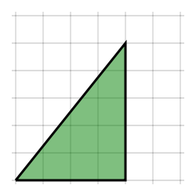 | [1]
2) Find the area of the triangle using the grid of centimetre squares  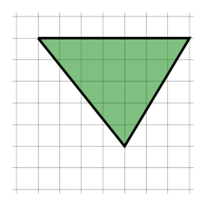 | [1]
3) Find the area of the triangle  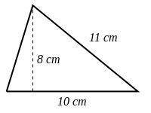 | [1]
4) Find the area of the triangle  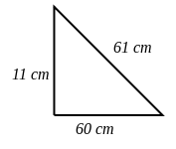 | [1]
5) Find the area of the triangle  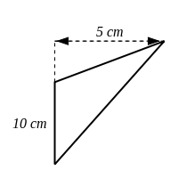 | [1]
6) Find the area of the right-angled triangle  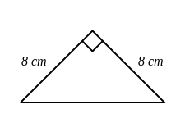 | [1]
7) Find the area of a triangle, given that it has a base of 8 cm and a perpendicular height to the base of 5 cm. | [1]
Solutions for the assessment Area of a Triangle
1) Area is 10 $cm^{2}$ | 2) Area is 17.5 $cm^{2}$
3) Area = 40 $cm^{2}$ | 4) Area = 330 $cm^{2}$
5) Area = 25 $cm^{2}$ | 6) Area = 32 $cm^{2}$
7) Area = 20 $cm^{2}$

