Area of Rectangles and Triangles
Name : | Class : | Date :

Mark : | /8 | %

1) Estimate the area of the triangle by counting unit squares  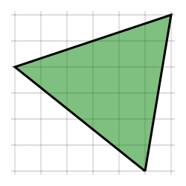 Area is about ......... unit squares | [1]
2) Estimate the area of the quadrilateral by counting unit squares  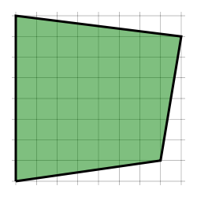 Area is about ......... unit squares | [1]
3) Find the area of the grid. Key: = 1 unit square  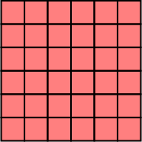 Area = ......... unit squares | [1]
4) Find the area of the square.  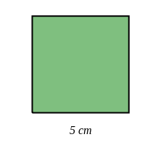 Area = ......... cm² | [1]
5) Find the area of a rectangle, given that it has sides of length 10 centimetres and 5 centimetres.  Area = ......... cm² | [1]
6) Find the area of the triangle.  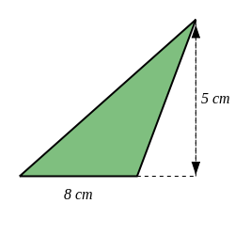 Area = ..... cm² | [1]
7) Find the area of the shape. Each square on the grid is 1 cm².  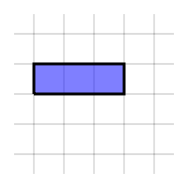 Area = ......... cm² | [1]
8) Find the area of the shape below.  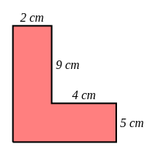 Area = ..... $cm^{2}$ | [1]
Solutions for the assessment Area of Rectangles and Triangles
1) Area is about 17 unit squares | 2) Area is about 53 unit squares
3) Area = 6 $×$ 6 = 36 unit squares | 4) Area = 25 cm²
5) Area = 50 cm² | 6) Area = 20 $cm^{2}$
7) Area = 3 cm² | 8) Area = 48 $cm^{2}$

