Construct Expressions, Formula and Equations
Name : | Class : | Date :

Mark : | /12 | %

1) Write an algebraic expression for the sentence below (use the letter n to represent the missing number):  Double a number | [1]
2) I start a game with $b$ marbles and lose $c$ marbles. Write down a formula for the number, $S$, of marbles that I finish with. | [1]
3) Using the letter n, write an equation to represent the following:  I'm thinking of a number. I double it then add 4 and get an answer of 16. | [1]
4) a) Using the letter n to represent the missing number, write an equation for the following:  I'm thinking of a number. I double it then add 5 and get an answer of 17.  b) Solve your equation to find the missing number | [1]
5) Find, in its simplest form, the perimeter of the shape given below in terms of $z$.  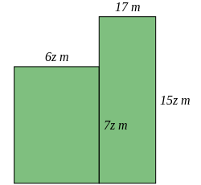 | [1]
6) Write down a fully simplified formula for the perimeter, $P$, of the isosceles triangle given below  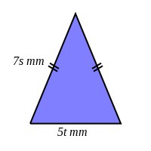 | [1]
7) Write down a fully simplified formula for the perimeter, $P$, of the isosceles triangle given below  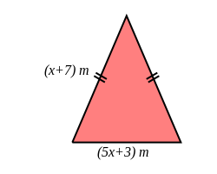 | [1]
8) Write a formula using the letters and numbers given below  a) Triple a number $c$ and add 8  b) A number $P$ is equal to the sum of a number $b$ and the square of $c$. | [2]
9) I buy $d$ kg of oranges and $e$ kg of pineapples. Write down a formula for $P$ if $P$ kg is the weight of the fruit that I bought | [1]
10) Jon has two trees in his garden. One is 4 metres taller than the other. If we let $h$ be the height of the shorter tree, write an algebraic expression for the sum of the two trees' heights. | [1]
11) Write down a formula for the perimeter, $P$, of the rectangle given below  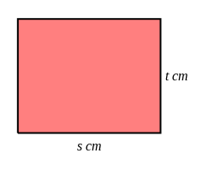 | [1]
Solutions for the assessment Construct Expressions, Formula and Equations
1) 2 $n$ | 2) $S=$ $b-c$
3) $2n+4=16$ | 4) a) $2n+5=17$, b) $n$=6
5) $P$ = (42z + 34) $m$ | 6) $P$ = (14s + 5t) mm
7) $P$ = (7x + 17) $m$

8) a) $3c+8$ | b) $P$ = $b+c^{2}$
9) $P=$ $d+e$ | 10) $2h+4$
11) $P$ = (2s + 2t) cm

