Construct Expressions, Formula and Equations
Name : | Class : | Date :

Mark : | /12 | %

1) Write an algebraic expression for the sentence below (use the letter n to represent the missing number):  Subtract 2 from a number | [1]
2) If $a$ cm is the length of a rectangle and $b$ cm is the width, write down a formula for $A$ if the perimeter of the rectangle is $A$ cm. | [1]
3) Using the letter n, write an equation to represent the following:  I'm thinking of a number. I triple it then subtract 4 and get an answer of 14. | [1]
4) a) Using the letter n to represent the missing number, write an equation for the following:  I'm thinking of a number. I triple it then add 2 and get an answer of 20.  b) Solve your equation to find the missing number | [1]
5) Find, in its simplest form, the perimeter of the shape given below in terms of $a$.  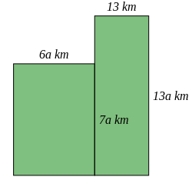 | [1]
6) Write down a fully simplified formula for the perimeter, $P$, of the isosceles triangle given below  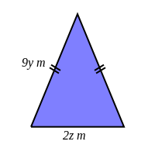 | [1]
7) Write down a fully simplified formula for the perimeter, $P$, of the rectangle given below  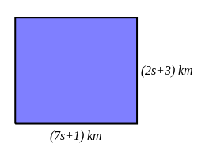 | [1]
8) Write a formula using the letters and numbers given below  a) Triple a number $x$ and add 7  b) A number $T$ is equal to the sum of two numbers $y$ and $z$. | [2]
9) Pears cost $b$ pence each and I buy 10 of these pears. Write down a formula for $W$ where $W$ p is the total cost of the pears. | [1]
10) Jon has two trees in his garden. One is 35 metres taller than the other. If we let $h$ be the height of the shorter tree, write an algebraic expression for the sum of the two trees' heights. | [1]
11) Write down a formula for the perimeter, $P$, of the rectangle given below  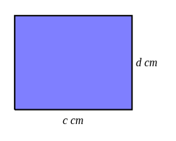 | [1]
Solutions for the assessment Construct Expressions, Formula and Equations
1) $n-2$ | 2) $A=$ $2a+2b$
3) $3n-4=14$ | 4) a) $3n+2=20$, b) $n$=6
5) $P$ = (38a + 26) km | 6) $P$ = (18y + 2z) $m$
7) $P$ = (18s + 8) km

8) a) $3x+7$ | b) $T$ = $y+z$
9) $W=$ $10b$ | 10) $2h+35$
11) $P$ = (2c + 2d) cm

