Construct Expressions, Formula and Equations
Name : | Class : | Date :

Mark : | /12 | %

1) Write an algebraic expression for the sentence below (use the letter n to represent the missing number):  Triple a number | [1]
2) If $b$ cm is the length of a rectangle and $c$ cm is the width, write down a formula for $W$ if the perimeter of the rectangle is $W$ cm. | [1]
3) Using the letter n, write an equation to represent the following:  I'm thinking of a number. I triple it then add 2 and get an answer of 26. | [1]
4) a) Using the letter n to represent the missing number, write an equation for the following:  I'm thinking of a number. I double it then subtract 3 and get an answer of 11.  b) Solve your equation to find the missing number | [1]
5) Find, in its simplest form, the perimeter of the shape given below in terms of $b$.  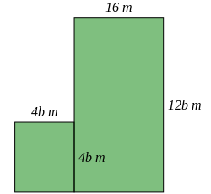 | [1]
6) Write down a fully simplified formula for the perimeter, $P$, of the rectangle given below  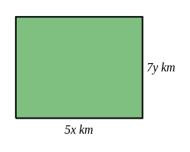 | [1]
7) Write down a fully simplified formula for the perimeter, $P$, of the rectangle given below  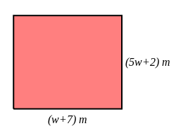 | [1]
8) Write a formula using the letters and numbers given below  a) Triple a number $h$ and add 3  b) A number $W$ is equal to twice the product of two numbers $y$ and $z$. | [2]
9) If $b$ cm is the length of a rectangle and $d$ cm is the breadth, write down a formula for $P$ if the perimeter of the rectangle is $P$ cm | [1]
10) Jon has two trees in his garden. One is 10 metres taller than the other. If we let $z$ be the height of the shorter tree, write an algebraic expression for the sum of the two trees' heights. | [1]
11) Write down a formula for the perimeter, $P$, of the rectangle given below  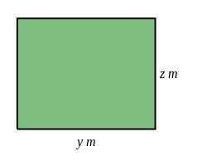 | [1]
Solutions for the assessment Construct Expressions, Formula and Equations
1) 3 $n$ | 2) $W=$ $2b+2c$
3) $3n+2=26$ | 4) a) $2n-3=11$, b) $n$=7
5) $P$ = (32b + 32) $m$ | 6) $P$ = (10x + 14y) km
7) $P$ = (12w + 18) $m$

8) a) $3h+3$ | b) $W$ = $2yz$
9) $P=$ $2b+2d$ | 10) $2z+10$
11) $P$ = (2y + 2z) $m$

