Fractions of grids and shapes
Name : | Class : | Date :

Mark : | /10 | %

1) What fraction is the shaded part of the grid? ......... | [1]
2) What fraction is the shaded part of the grid? ......... | [1]
3) What fraction is the shaded part of the grid? .........  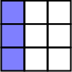 | [1]
4) Work out the fraction of the shape below that is coloured. ......... | [1]
5) Work out the fraction of the shape below that is coloured. .........  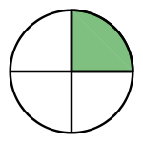 | [1]
6) Work out the fraction of the shape below that is coloured, giving your answer as a fraction in its lowest terms. .........  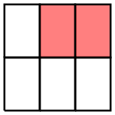 | [1]
7) Work out the fraction of the shape below that is coloured. ......... | [1]
8) Work out the fraction of the shape below that is coloured. .........  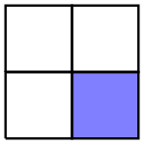 | [1]
9) Work out the fraction of the shape below that is coloured, giving your answer as a fraction in its lowest terms. .........  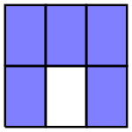 | [1]
10) Work out the fraction of the shape below that is coloured, giving your answer as a fraction in its lowest terms. .........  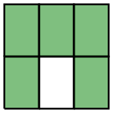 | [1]
Solutions for the assessment Fractions of grids and shapes
1) $\frac{2}{9}$ | 2) $\frac{1}{5}$
3) $\frac{1}{3}$ | 4) $\frac{1}{2}$
5) $\frac{1}{4}$ | 6) $\frac{1}{3}$
7) $\frac{1}{2}$ | 8) $\frac{1}{4}$
9) $\frac{5}{6}$ | 10) $\frac{5}{6}$

