**A24** RECOGNISE AND USE SEQUENCES OF TRIANGULAR, SQUARE AND CUBE NUMBERS, SIMPLE ARITHMETIC PROGRESSIONS, FIBONACCI TYPE SEQUENCES, QUADRATIC SEQUENCES, AND SIMPLE GEOMETRIC PROGRESSIONS (*rn* WHERE *n* IS AN INTEGER, AND *r* IS A RATIONAL NUMBER > 0) (foundation tier)

**SPECIAL SEQUENCES**

Before we look at higher level sequences, here are some important sequences that you should know.

**Odd numbers**

1 3 5 7 9 11 ....... 2*n* − 1

**Even numbers**

2 4 6 8 10 12 ....... 2*n*

**Square numbers**

1 4 9 16 25 36 ....... *n*2

**Cube numbers**

1 8 27 64 125 216 ....... *n*3

**Triangle numbers**

1 3 6 10 15 21 ....... *n*(*n* + 1)

**Prime numbers**

2 3 5 7 11 13 ....... ?

**Note:** there is no formula for calculating the *n*th term for prime numbers.

**Fibonacci**

1 1 2 3 5 8 13 21 .......

**The Fibonacci sequence**

The Fibonacci numbers are nature's numbering system. They appear everywhere in nature, from the leaf arrangement in plants, to the pattern of the florets of a flower, the bracts of a pine cone, or the scales of a pineapple. The Fibonacci numbers are therefore applicable to the growth of every living thing, including a single cell, a grain of wheat, a hive of bees, and even all of mankind.

Many plants show the Fibonacci numbers in the arrangement of the leaves around the stem. Some pine cones and fir cones also show the numbers, as do daisies and sunflowers. Sunflowers can contain the number 89, or even 144.

Many other plants, such as succulents, also show the numbers. Some coniferous trees show these numbers in the bumps on their trunks and palm trees show the numbers in the rings on their trunks

The Fibonacci numbers are the numbers in the following integer sequence, called the **Fibonacci sequence:**

1 1 2 3 5 8 13 21 .......

The next number is found by adding up the two numbers before it.

The rule is

*xn* = *xn*–1 + *xn*–2

where

*xn* = term number *n*

*xn*–1 = previous term *n* – 1

*xn*–2 = the term before the previous term *n* – 2

For example, the 20th term = 19th term + 18th term.

Using these ideas

The 9th term of 1 1 2 3 5 8 13 21 .......

is

*x*9 = *x*8 + *x*7 or next term = sum of the previous two terms

*x*9 = 21 + 13 = 34

Here are the first five terms of the Fibonacci sequence

0 1 1 2 3

This is how we can find the next 5 terms:

**RULE:** Fibonacci sequence is, the next term in the sequence is the sum of the two previous terms.

0 1 1 2 3 5

2 + 3

0 1 1 2 3 5 8

3 + 5

0 1 1 2 3 5 8 13

5 + 8

0 1 1 2 3 5 8 13 21

8 + 13

0 1 1 2 3 5 8 13 21 34

13 + 21

Hence the first 10 terms of the Fibonacci sequence are:

0 1 1 2 3 5 8 13 21 34

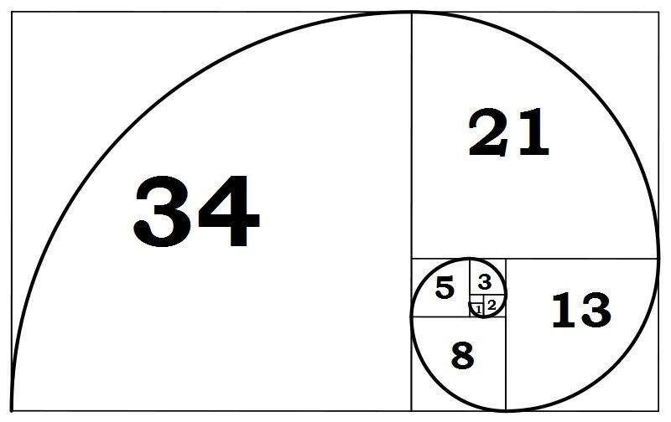

**EXAMPLE 1**

Find the first ten terms of the Fibonacci sequence

2 5 7 12 19

The rule to continue a Fibonacci sequence is:

The next term in the sequence is the sum of the two previous terms.

The first 5 terms given are: 2 5 7 12 19

The 6th term = 12 + 19 = 31 6th term = 4th term + 5th term

The 7th term = 19 + 31 = 50 7th term = 5th term + 6th term

The 8th term = 31 + 50 = 81 8th term = 6th term + 7th term

The 9th term = 50 + 81 = 131 9th term = 7th term + 8th term

The 10th term = 81 + 131 = 212 10th term = 8th term + 9th term

Thus, the first 10 terms are:

2 5 7 12 19 31 50 81 131 212

**EXERCISE:**

1. The first fifteen Fibonacci numbers are:

1 1 2 3 5 8 13 21 34 55 89 144 233 377 610

What type of number is every third term?

2. Find the first ten terms of the following Fibonacci sequences.

(a) 2 3 5 8 (b) 1 3 4 7

(c) 2 7 9 16 (d) 3 8 11 19

(e) 1 6 7 13 (f) 0 3 3 6

(g) 10 11 21 32 (h) 7 11 18 29

(i) 20 20 40 60 (j) 50 65 115 180

3. A Fibonacci sequence has second term 20 and fifth term 80. Find the first term.

4. The sixth and seventh terms of a Fibonacci sequence are 31 and 50.

What are the first two terms of the sequence?

**5. If you take the first ten terms of any Fibonacci sequence, the sum of those 10 terms is equal to the 7th term multiplied by 11.**

**Show that this is true for the following Fibonacci sequence**

4 5 9 14

6. When you find the sum of the first six numbers of a Fibonacci sequence the sum is always four times the fifth number in the sequence.

**Show that this is true for the following Fibonacci sequence**

3 7 10 17

**ANSWERS**

1. An even number

2. (a) 13, 21, 34, 55, 89, 144 (b) 11, 18, 29, 47, 76, 123

(c) 25, 41, 66, 107, 173, 280 (d) 30, 49, 79, 128, 207, 335

(e) 20, 33, 53, 86, 139, 225 (f) 9, 15, 21, 36, 57, 93

(g) 53, 85, 138, 223, 361, 584 (h) 47, 76, 123, 199, 322, 521

(i) 100, 160, 260, 420, 680, 1100 (j) 295, 475, 770, 1245, 2015, 3260

3. 10

4. 2,5

5. Sum of the first 10 terms = 660

7th term × 11 = 60 × 11 = 660

6. Sum of the first 6 terms = 108

5th term × 4 = 27 × 4 = 108