Further Trigonometry
Revision Notes
Area of a Triangle
$$Area=\frac{1}{2}absinC$$

e.g
A
C
B
b
c
a
8.7m
23.1m

44º

Label the angles using capital ‘A’, ‘B’ and ‘C’. Make sure you label the angle that you are given ‘C’ as this is the letter that is attached to the ‘sin’ bit of the rule. It does not matter which way round you label the other angles.

Label the sides using lower case ‘a’, ‘b’ and ‘c’. The side opposite to angle ‘A’ is side ‘a’, the side opposite to angle ‘B’ is side ‘b’ and the side opposite to angle ‘C’ is side ‘c’.

Substitute the values into the rule.

$$Area=\frac{1}{2}absinC$$
$$Area=\frac{1}{2}×8.7×23.1×sin44$$

$$Area=69.8m^{2}(1dp)$$

Key points
- Only use this rule to find the area of a triangle if you are not given the base and the height otherwise you should use ½ x base x height.
- Make sure that you enter the values into your calculator carefully.
- Remember to include the correct units.

Sine Rule
Finding a side -
$$\frac{a}{sinA}=\frac{b}{sinB}=\frac{c}{sinC}$$

Finding an angle –
$$\frac{sinA}{a}=\frac{sinB}{b}=\frac{sinC}{c}$$

Using the sine rule to find a missing side
A
C
B
b
c
a
X
23.1m

78º

58º

Label the angles using capital ‘A’, ‘B’ and ‘C’.

Label the sides using lower case ‘a’, ‘b’ and ‘c’. The side opposite to angle ‘A’ is side ‘a’, the side opposite to angle ‘B’ is side ‘b’ and the side opposite to angle ‘C’ is side ‘c’.

When using the sine rule, you only need to use two out of the three sections of the rule. For this example, we only have information about angle ‘A’ and angle ‘B’, we are trying to find side ‘a’ and we have the length of side ‘B’.
Therefore we would use –
$$\frac{a}{sinA}=\frac{b}{sinB}$$

Substitute the values into the rule.
$$\frac{x}{sin58}=\frac{23.1}{sin78}$$

Rearrange to find x.
$$x=\frac{23.1}{sin78}×sin58$$

$$x=20.03m(2dp)$$

Using the sine rule to find a missing angle
A
C
B
b
c
a
5.8cm
11.2cm
x

31º

Label the angles using capital ‘A’, ‘B’ and ‘C’.

Label the sides using lower case ‘a’, ‘b’ and ‘c’. The side opposite to angle ‘A’ is side ‘a’, the side opposite to angle ‘B’ is side ‘b’ and the side opposite to angle ‘C’ is side ‘c’.

When using the sine rule, you only need to use two out of the three sections of the rule. For this example, we only have information about side ‘B’ and side ‘C’, we are trying to find angle ‘B’ and we have the size of angle ’C’.
Therefore we would use –
$$\frac{sinB}{b}=\frac{sinC}{c}$$
Substitute the values into the rule.
$$\frac{sinx}{7.2}=\frac{sin31}{5.8}$$
Rearrange to find x.
$$sinx=\frac{sin31}{5.8}×11.2$$

$$sinx=0.99455628258$$

$$x=\sin^{-1}{(0.99455628258)}$$
$$x={84.02}^{o}(2dp)$$

Key points
- Only use the sine rule if the triangle is not a right angle triangle. If the triangle is a right angle triangle then use basic trigonometry.
- To use the sine rule to answer a question, you must have values for a complete pair i.e the length of a side and corresponding angle, and have the either the side that corresponds to the angle you are trying to find or the angle that corresponds to the side you are trying to find.
- Make sure that you enter the values into your calculator carefully.
- Remember to include the correct units.
Cosine Rule
Finding a side –
$$a^{2}=b^{2}+c^{2}-2bccosA$$

Finding an angle –
$$cosA=\frac{b^{2}+c^{2}-a^{2}}{2bc}$$

Using the cosine rule to find a missing side
A

37º
c
67mm
b

79mm

B

a
X
C

Label the angles using capital ‘A’, ‘B’ and ‘C’.

Label the sides using lower case ‘a’, ‘b’ and ‘c’. The side opposite to angle ‘A’ is side ‘a’, the side opposite to angle ‘B’ is side ‘b’ and the side opposite to angle ‘C’ is side ‘c’. Make sure you label the angle that you are given ‘A’ as this is the letter that is attached to the ‘cos’ bit of the rule. It does not matter which way round you label the other angles.

Substitute the values into the rule.

$$a^{2}=b^{2}+c^{2}-2bccosA$$
$$a^{2}={67}^{2}+{79}^{2}-(2×67×79×cos37)$$
$$a^{2}=4489+6241-8454.3555$$
$$a^{2}=2275.6445$$
$$a=\sqrt{2275.6445}=47.7mm(1dp)$$

Using the cosine rule to find a missing angle
A
C
B
b
a
3.6cm
3.8cm
X
4.2cm
e.g

c

Label the angles using capital ‘A’, ‘B’ and ‘C’.

Label the sides using lower case ‘a’, ‘b’ and ‘c’. The side opposite to angle ‘A’ is side ‘a’, the side opposite to angle ‘B’ is side ‘b’ and the side opposite to angle ‘C’ is side ‘c’. Make sure you label the angle that you are finding ‘A’ as this is the letter that is attached to the ‘cos’ bit of the rule. It does not matter which way round you label the other angles.
Substitute the values into the rule.
$$cosA=\frac{b^{2}+c^{2}-a^{2}}{2bc}$$

$$cosx=\frac{{3.6}^{2}+{4.2}^{2}-{3.8}^{2}}{2×3.6×4.2}$$

$$cosx=\frac{12.96+17.64-14.44}{30.24}$$

$$x=\cos^{-1}\left(\frac{16.16}{30.24}\right)$$

$$x={57.7}^{o}(1dp)$$
Key Points
- Only use the cosine rule if the triangle is not a right angle triangle. If the triangle is a right angle triangle then use basic trigonometry.
- Use the cosine rule to find an angle if you are given the length of all sides of the triangle and no angles.
- Use the cosine rule to find the length of a missing side if you are given the corresponding angle and the length of the other two sides.
- Make sure that you enter the values into your calculator carefully.
- Remember to include the correct units.
Exam Questions

Q1.

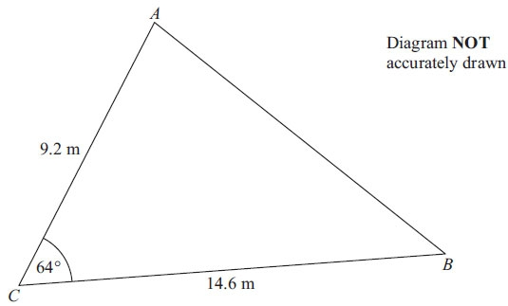
AC = 9.2 m
BC = 14.6 m
Angle ACB = 64°
(a) Calculate the area of the triangle ABC.
Give your answer correct to 3 significant figures.

. . . . . . . . . . . . . . . . . . . . . . m²
(2)
(b) Calculate the length of AB.
Give your answer correct to 3 significant figures.

.......................................................................................................................................
(3)
(Total for Question is 5 marks)
Q2.
ABC is a triangle.
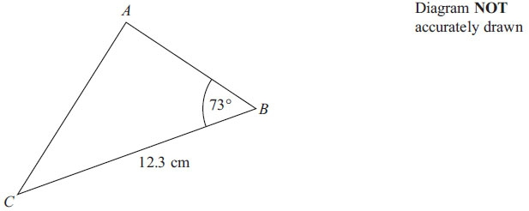
BC = 12.3 cm
Angle ABC = 73°
The area of triangle ABC is 50 cm².
Work out the length of AC.
Give your answer correct to 3 significant figures.

.......................................................................................................................................
(Total for Question is 6 marks)

Q3.
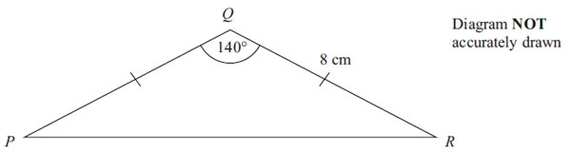
Calculate the length of PR.
Give your answer correct to 3 significant figures.

.......................................................................................................................................
(Total for Question is 3 marks)

Q4.
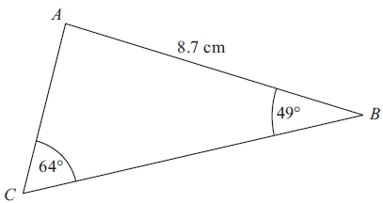 Diagram NOT accurately drawn
ABC is a triangle.
AB = 8.7 cm.
Angle ABC = 49°.
Angle ACB = 64°.
Calculate the area of triangle ABC.
Give your answer correct to 3 significant figures.

. . . . . . . . . . . . . . . . . . . . . cm²
(Total for Question is 5 marks)

Q5.
ABCD is a quadrilateral.
Diagram NOT
accurately drawn

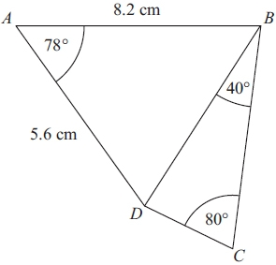

Work out the length of DC.
Give your answer correct to 3 significant figures.

......................................................................................................................................
(Total for Question is 6 marks)

Mock Exam Question

