Study Programme

Week A: Percentages

1. Calculate:

- 10% of £50

- 30% of 250kg
- 17.5% 0f £60

- In a sale, a jacket costing £40 is reduced by 20%. What is the sale price?

- Increase £39 by 15%

- A car dealer buys a car for £500, gives it a clean, and then sells it for £640. What is his percentage profit?

5. Mrs. Evans decides to take 863 students on a trip to Euro Disney. They travel by coach.
Each coach can hold up to 51 students.

a Work out the smallest number of coaches Mrs. Evans should book so that all the students can go on the trip. You MUST show ALL your working

Each student has to pay £37 for the trip. 745 students decide to go on the trip.
b How much money is collected if all 745 students pay £37 each.

The trip actually cost £25 000
c Use your calculator to work out the percentage loss that Mrs. Evans will make on the trip.

6. Mustapha pays Income Tax at 22%.
He is allowed to earn £3 500 before he pays any Income Tax. He earns £12 500 in one year.
Work out how much Income Tax he pays in that year.

7. Astrid bought a motor car for £10 000 on the First of January 1996.

It lost 15% of its value during 1996 and then 10% during every year from the First of January 1997.
Work out the value of the car on the First of January 1999.

Week B: Compound Interest

  - £840 is borrowed for 2 years at 8% per annum. Find the compound interest.

  - Shreena put £484 in a new savings account. At the end of every year, interest of 4.3% was added to the amount in her savings account at the start of that year.
Calculate the total amount in Shreena's savings account at the end of 2 years.

  - At present the population of a country is increasing at 1% per year. If it continues to increase at the same rate, in how many years’ time will the population double?

_____________________________________________________________________________

Week C: Solving Equations

Factorise the following expressions:

- 3x + 12 =

- 2m + 6k =

- 3x - 12xy =
- 3x² + 12x =

- 5x²y + 20xy² =

Solve the following equations:

- 5n = 40

- 35 = 7y

- 3p = 8

- ^{p}/₃ = 4

- ^{x}/₇ = 7

- ¹/₂ x = 9

- ¹/₅ p = 8

- 2p + 7 = 15

- 7h – ¹/₂ = 20¹/₂

- ^{x}/₅ + 6 = 12

- 10 – ^{n}/₂ = 7

- 3(w + 2) = 27

- 13(p – 3) = 52

- x + 7 = 2
2

- 5x – 1 = 1
3

Questions with x on both sides of the equals (=) sign

- 2x + 6 = 3x + 2

- 15 – 5x = 3x
- 7(x + 3) = 4(x – 2)

- 3(2 – 2x) – 4(3 + 3x) = 3(2 – 3x)

_____________________________________________________________________________

Week D: Forming & Solving Equations

- If I multiply a number by 3 and then add 5 the answer is 17. What is my number?

- The angles of a triangle are: x, x + 40º and 3x, what is the value of the largest angle?

_____________________________________________________________________________

Week E: Inequalities

Draw the following inequalities on a number line

- x > 3

- x < -5

- 3 < x < 7

- –2 < x ≤ 0

Solve the following Inequalities

- x + 1 > 7

- 3x ≤ 15

- 6x – 8 < 4x + 2

- – 3x > 18

Week F: Rearranging Formulae

A: Rearrange each of the following to make the letter indicated in (brackets) the subject

- C = πD (D)

- y = mx + c (c)

- v = πr²h (h)

- s = ut + ¹/₂at² (a)

- N = 2π√l (l)

- x = 2a + b² (b)

B. The velocity of a particle is given by the formula:
v ² = u ² + 2as
- Calculate the value of the velocity v when u = -5, a = and s = 5.67.
- Rearrange the formula to make u the subject.

________________________________________________________________________
Week G: Simultaneous Equations

Solve the following equations simultaneously to find the values of both x and y

a + 3b = 7
a – 3b = 25

2x – y = 7
x – y = 3

Week H: More Simultaneous Equations
Solve the following simultaneously to find the values of both x and y. The difference here is that the coefficients of (the numbers in front) x and y are different, thus requiring you to create a 3rd and maybe a 4th equation.

3x + 2y = 12
2x + y = 7

7x + 5y = 66
3x – 4y = 16

Week I: Drawing Graphs

A: Complete the table of values and the plot the straight-lines graphs on the axes below:
y = x + 2
x | -2 | -1 | 0 | 1 | 2 | 3
y |  |  | 2

y = 3x - 1
x | -2 | -1 | 0 | 1 | 2 | 3
y

y = 6 – x
x | -2 | -1 | 0 | 1 | 2 | 3
y

y = ^{x}/₂ + 5
x | -2 | -1 | 0 | 1 | 2 | 3
y


B: (a) On the grid below draw the graph of y = x² - 3x – 5 for values of x between -2 and +5

x | -2 | -1 | 0 | 1 | 2 | 3 | 4 | 5
y
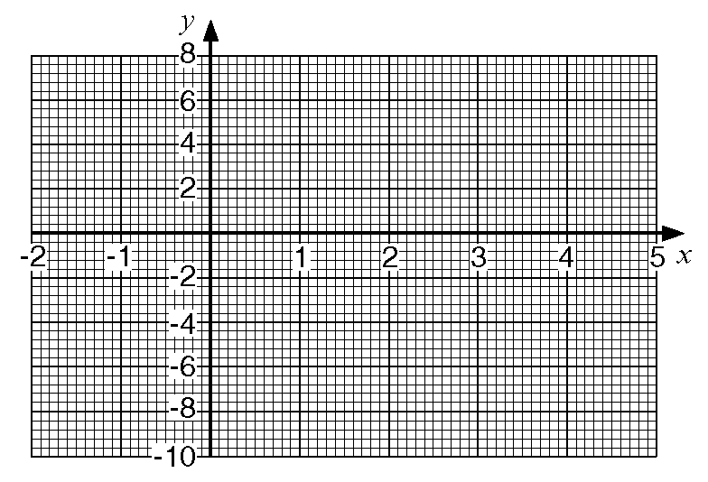

(b) Use your graph to solve the equation x² - 3x - 5 = 0

NB: Quadratic Equations produce smooth curves (no rulers please) – ∪-shape or ∩-shape.

Week J: Calculating Averages & Grouped Data

1. A survey was carried out to find how much time was needed by a group of pupils to complete homework set on a particular Monday evening.
The results are shown in the table below.

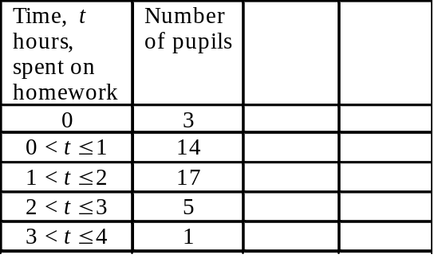
1a. Calculate an estimate for the mean time spent on homework by the pupils in the group.

2. Pippa collected data for the heights (h) of the students in her class.
Here is the grouped frequency table of her results.

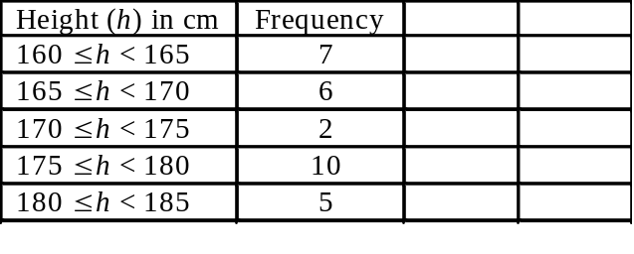2a Use the table to calculate an ‘estimate of the mean’ for her results.
2b Complete the cumulative frequency table for Pippa's data and hence draw a cumulative frequency graph for the data.
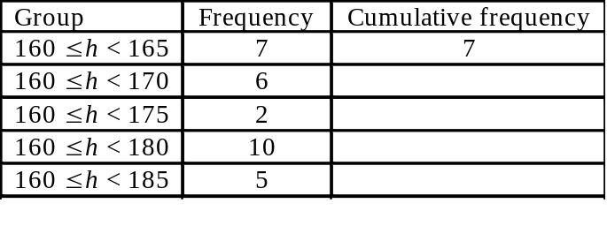
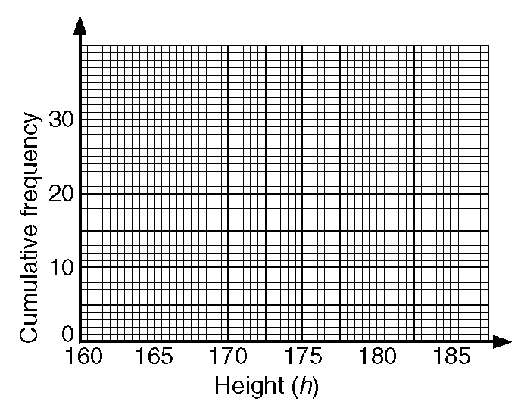

2c Use the cumulative frequency graph to calculate an estimate of
i median of the data

ii interquartile range of the data.

Week K: Expanding Brackets – (Pre-requisite to Solving Quadratic Equations)

A: Expand and simplify the following - get rid of the brackets first.

- 2a(4 - a)

- (x + 2)(x + 3)

- (2c + 3)(c - 4)

________________________________________________________________________
Week L: Solving Quadratics by Factorising

Example: x² + 5x + 6 = 0 factorised is (x + 2)(x + 3) = 0 such that x = -2 and x = -3

- x² + 11x + 18 = 0

- x² + 5x - 6 = 0

- x² - 7x + 10 = 0

- x² - 8x - 20 = 0

_______________________________________________________________________
Week M: Solving Quadratic Equations by Completing the Square

- x² + 6x + 9 = 0

- x² - 6x + 7 = 0

- x² - x - 3 = 0

- x² + 3x - 1 = 0

_______________________________________________________________________________
Week N: Solving Quadratic Equations using The Formula
Use the formula given below to solve the following Quadratic Equations to 2.d.p
x = − b ± √(b² – 4ac)
2a

- x² + 6x + 3 = 0
- x² +3x - 1 = 0
- 2x² + 8x - 1 = 0

Week O: Solving Quadratic Equations using Graphs

Here is a graph of y = x² – 4x + 3. Use the graph to find the solutions to the following equations. Note: there are two solutions to each equation.

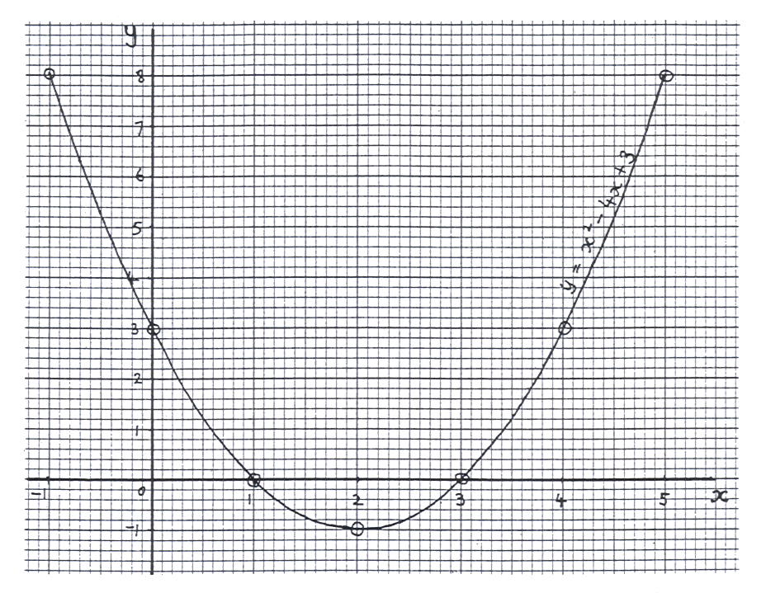

- x² – 4x + 3 = 0 x = _______ and x = _______
- x² – 4x + 3 = 3 x = _______ and x = _______
- x² – 4x + 1 = 3 x = _______ and x = _______
- x² – 4x - 4 = 1 x = _______ and x = _______

Week P: Pie Charts

1. Patrick carried out a survey of 45 pupils in Year 11.
He asked how many books they had borrowed from the library in the last month.
These are Patrick's results.

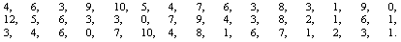

1a. Complete the frequency table.

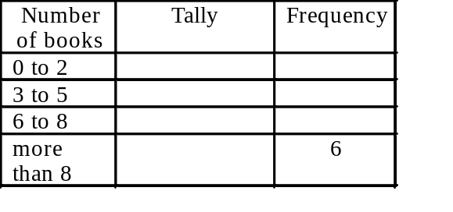

1b. Construct a pie chart to show this information.

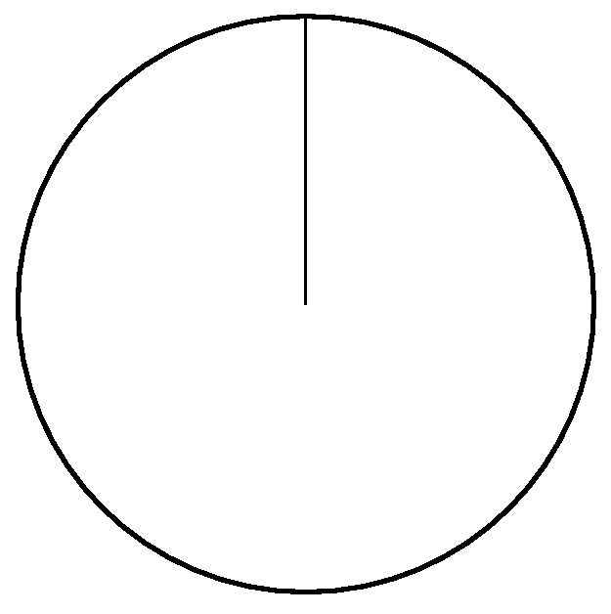

1c. What fraction of the group had borrowed 6, 7 or 8 books?

2. 50 pupils are going on an educational visit. The pupils have to choose to go to one of the theatre or the art gallery or the science museum.
23 of the pupils are boys.
11 of the girls choose to visit the theatre.
9 of the girls choose to visit the art gallery.
13 of the boys choose to visit the science museum.

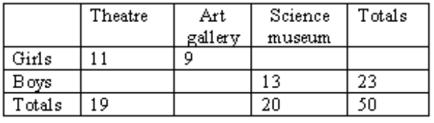
2a. Complete the table.

2b. How many of the girls choose to visit the science museum?

- The table lists the weights of twelve books and the number of pages in each one.

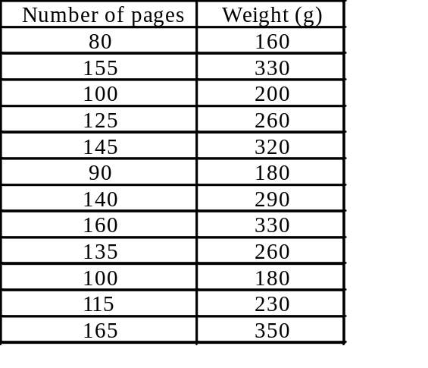
3a Draw a scatter graph to show the information in the table.
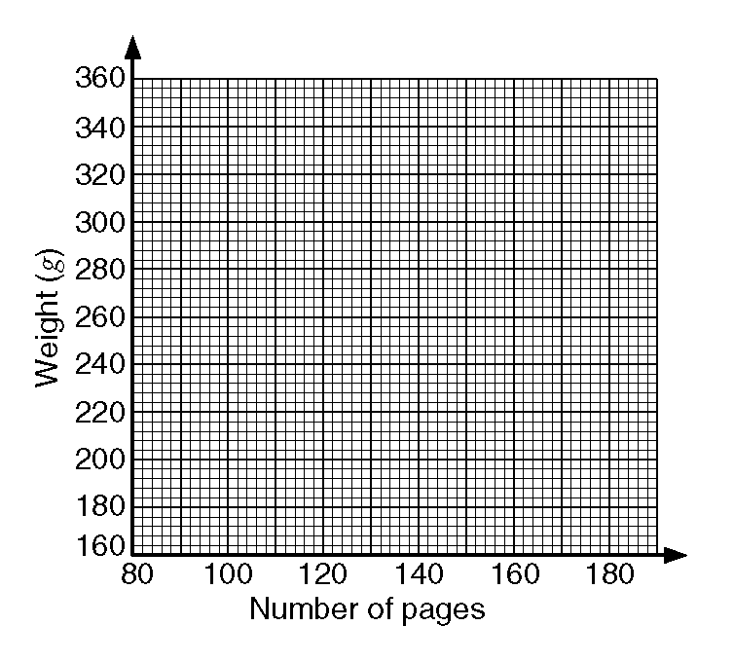3b. Describe the correlation between the number of pages in these books and their weights.

_______________________________________

Week Q: Trigonometry

1. In the diagram
AB = 17.9 m, BD = 8.2 m, angle CBD = 37º and angle BDC = 90º.

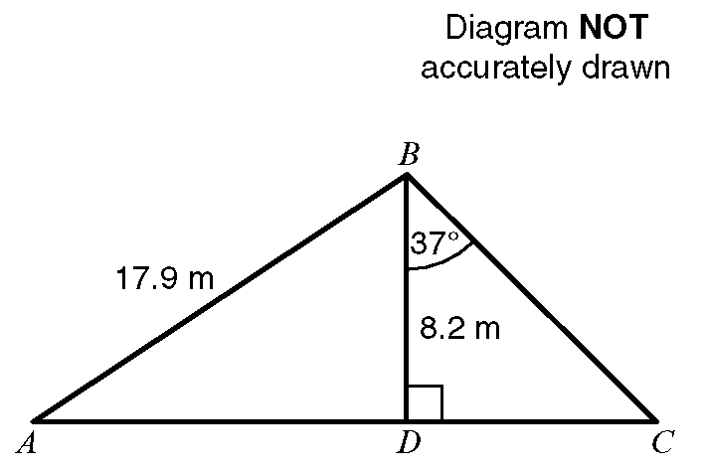

ADC is a straight line.
a Calculate the length of DC.
Give your answer, in metres, correct to 3 significant figures.

b Calculate the size of angle DAB.
Give your answer correct to 1 decimal place.

_______________________________________

Week R: More Trigonometry

2. Here is a side view of a swimming pool.
ABCD is a horizontal straight line. AH, BG, CF and DE are vertical lines.

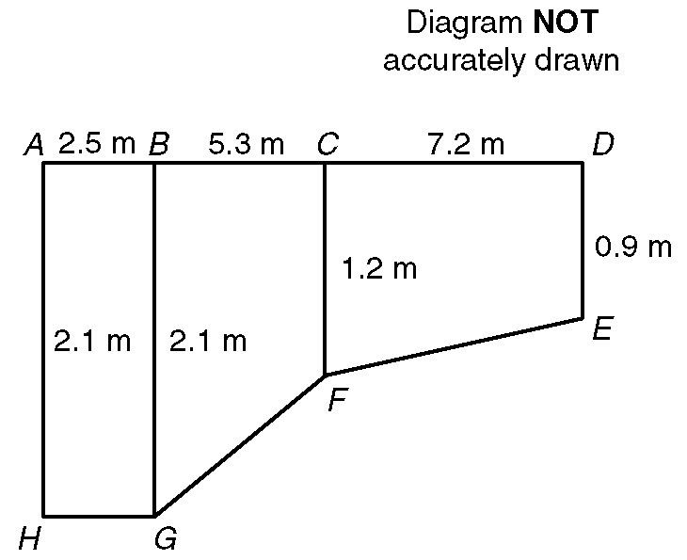

a Calculate the length of the line FG.
Give your answer correct to 3 significant figures.

b Calculate the angle that the line GF makes with the horizontal. Give your answer correct to 1 decimal place.

Week S: Pythagoras’ Theorem

1. Calculate the length of a diagonal of this rectangle.
Give your answer in centimetres correct to one decimal place.

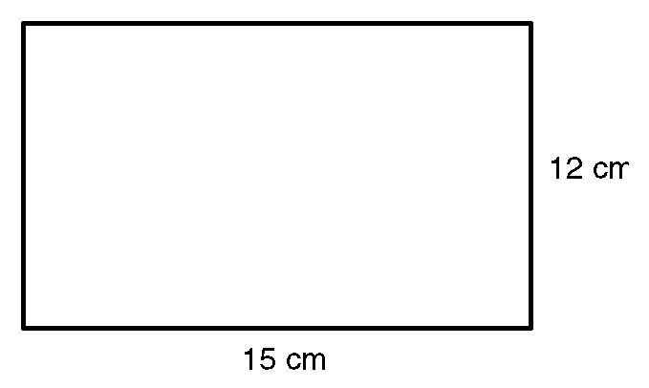

2. Sidney places the foot of his ladder on horizontal ground and the top against a vertical wall.
The ladder is 16 feet long.
The foot of the ladder is 4 feet from the base of the wall.
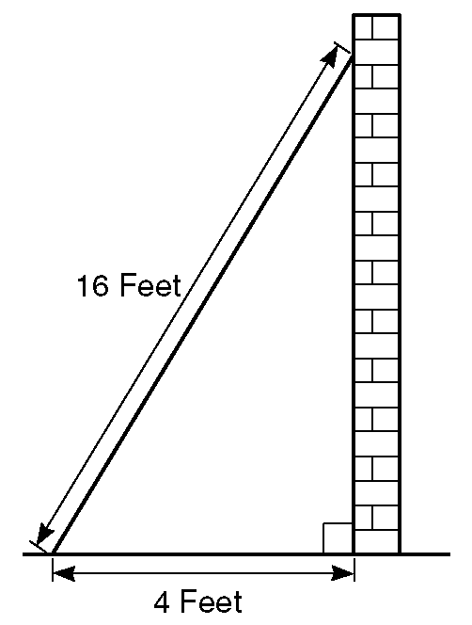

(a) Work out how high up the wall the ladder reaches. Give your answer to 3 significant figures.

(b) Work out the angle the base of the ladder makes with the ground. Give your answer to 3 significant figures.

3. The diagram is part of a map showing the positions of three Nigerian towns.

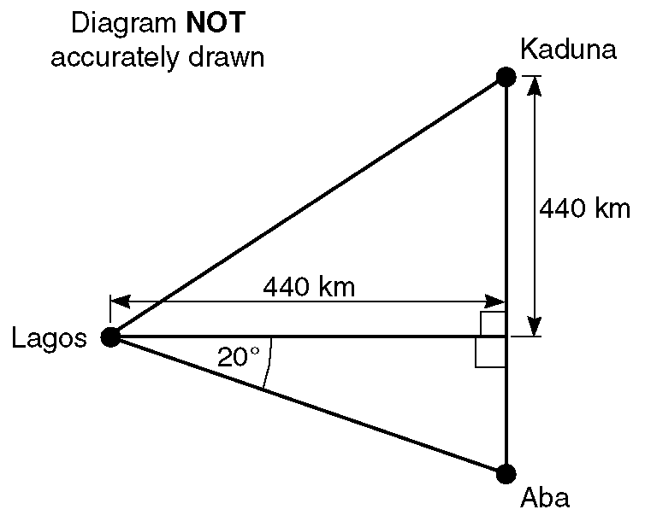

Kaduna is due North of Aba.

(a) Calculate the direct distance between Lagos and Kaduna. Give your answer to the nearest kilometre.

(b) Calculate the distance between Kaduna and Aba. Give your answer to the nearest kilometre.

_______________________________________

Week T: Probability & Tree Diagrams

- A fair coin is tossed and a fair dice is thrown. One possible outcome is (Heads, 4).List all the possible outcomes.

2. A fair dice is to be thrown.
(a) Write down the probability of the dice landing on
  - a six

(ii) an even number

A second dice is to be thrown.
The probability that this dice will land on each of the numbers 1 to 6 is given in the table.

The dice is to be thrown once.
(b) Calculate the value of x.

(c) Calculate the probability that the dice will land on a number higher than 3.

The dice is thrown 1000 times.
(d) Estimate the number of times the dice is likely to land on a six.

Number | 1 | 2 | 3 | 4 | 5 | 6
Probability | x | 0.2 | 0.1 | 0.3 | 0.1 | 0.2

3. There are 4 red balls, 5 blue balls and 3 green balls in a bag.
A ball is to be chose at random and replaced. A second ball is then to be chosen at random.

(a) Complete the tree diagram.

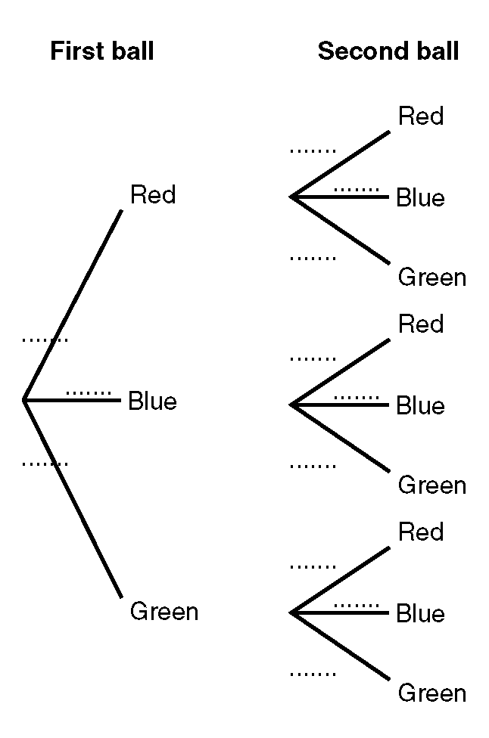

(b) Use the tree diagram to calculate the probability that both balls chosen will be:

(i) red

(ii) the same colour.

(c) Calculate the probability that exactly one of the balls chosen will be red.

Week U: Cumulative Frequency & The
Inter-quartile Range

A survey is made of all 120 houses on an estate. The floor are, in m², of each house is recorded.
The results are shown in the cumulative frequency table.

On the grid draw a cumulative frequency graph for the table.
Floor area (x) in m² | Cumulative Frequency
0 < x ≤ 100 | 4
0 < x ≤ 150 | 20
0 < x ≤ 200 | 49
0 < x ≤ 250 | 97
0 < x ≤ 300 | 114
0 < x ≤ 350 | 118
0 < x ≤ 400 | 120

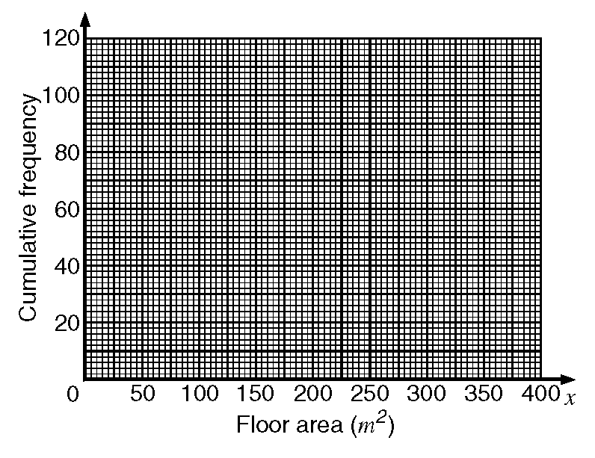

(b) Use your cumulative frequency graph to estimate the inter-quartile range of the floor areas of the houses.

The houses on the estate with the greatest floor areas are called luxury houses. 10% of the houses are luxury houses.

(c) Use your graph to estimate the minimum floor area for a luxury house.

__________________________________________

Week V: Revision of Angle Facts

a) The diagram shows a quadrilateral
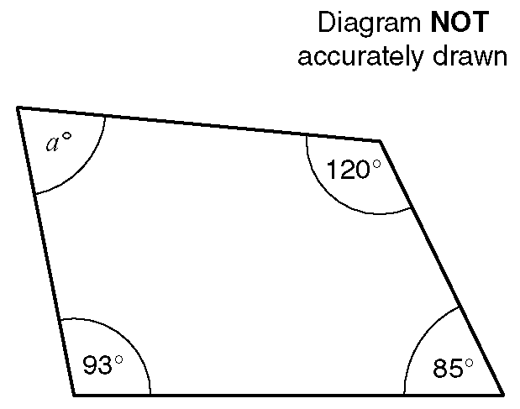

Work out the size of the angle marked aº.

(b) The diagram shows a regular hexagon.

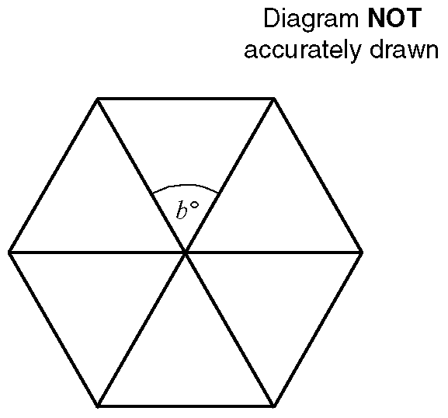

Work out the size of the angle marked bº.

(c) The diagram shows a regular octagon.

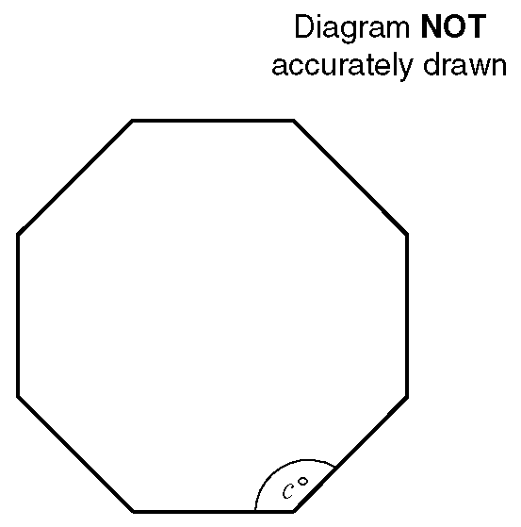
Work out the size of the angle marked cº.
Use your answer to work out the external angle of a regular octagon.

Mix Bag

I know the square numbers to 15 × 15? Ok, what is: (a) 14² (b) 13 x 13 =  (c) Square of 7 = 
(d) 11² =  (e) √(6²) =  (f) √121 = 

and what about cube numbers? (a) 2³ =  (b) Cube of 4 =  (c) 3³ + 2³ =  (d) 4³ = 

Estimate the answer to the following:

(a) (5.43 × 29.81) ÷ 32.15 (b) 961.39 ÷ (3.5 × 291.13) (c) √8.47 ÷ 2.85

Equations and Inequalties

a 3y + 7 = 28 b 2(3p + 2) = 19

c 3t - 4 = 5t – 10

d. On the number line below show the solution to this inequality
-7 ≤ 2x - 3 < 3
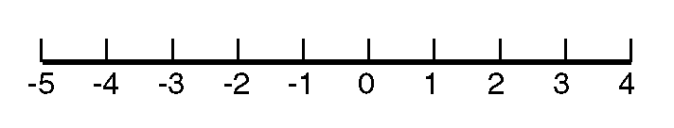

e. Solve the inequality
7y > 2y – 3

Number Sequences:
Write down the next two terms and work out the n^{th} -term for these sequences:

  - 2, 4, 6, 8, 10…

(b) 1, 3, 5, 7, 9…

  - 1, 1, 2, 3, 5, 8…

(d) 5, 7, 9, 11….

  - 1, 4, 9, 16, 25…

____________________________________________
  - 1, 8, 27, 64, 125…

  - 2, 4, 8, 16, 32…

  - 1, 3, 6, 10, 15…

  - -8, -2, 4, 10…

  - 2, 8, 18, 32, 50…

_______________________________________

Dimensions of Formula

- Draw a circle around each of the expressions which can be used to calculate an area.
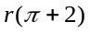 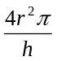 r(r + 4h) 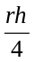

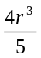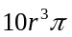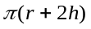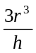

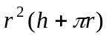

2. The diagram below represents a solid shape.

From the expressions below, choose the one that represents the volume of the solid shape.
π and are numbers which have no dimensions.
a, b and h are lengths.

π(b² - ab + a²), πh(b² + ab + a²), πh²(b² - a²),

π(a² + b²), πh²(b² - ab + a²).
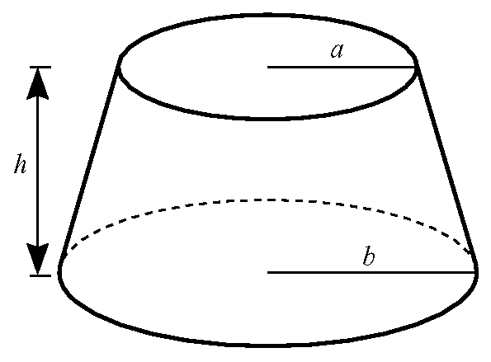

Write down the correct expression.

______________________________________________________________________________

Areas, Volumes & Angles

1. The diagram shows a cylinder.

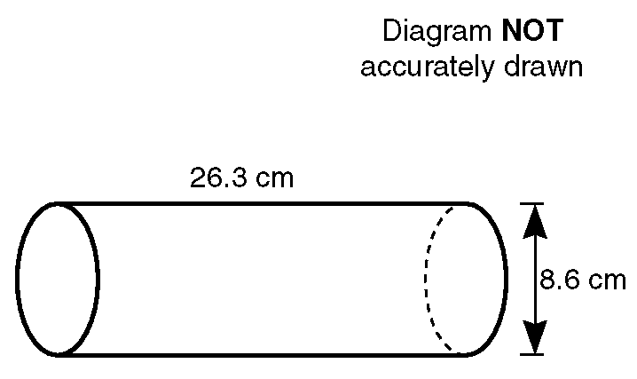

The height of the cylinder is 26.3 cm.
The diameter of the base of the cylinder is 8.6 cm.

Calculate the volume of the cylinder.
Give your answer correct to 3 significant figures.

- The diagram shows a triangular prism.
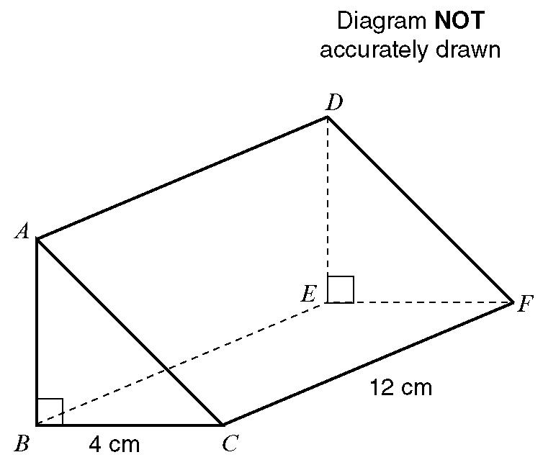
BC = 4 cm, CF = 12 cm and angle ABC = 90º. The volume of the triangular prism is 84 cm³. Work out the length of the side AB of the prism.

3. Some oil is spilt. The spilt oil is in the shape of a circle. The circle has a diameter of 12 cm.
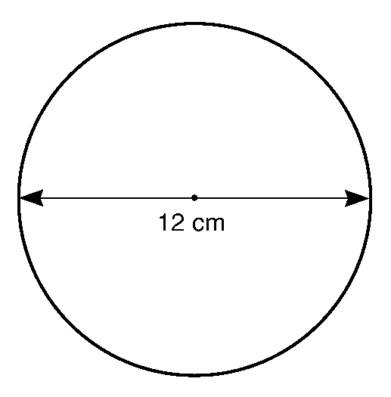
a Work out the circumference, in cm, of the spilt oil. Give your answer correct to 1 d.p.

The diameter of the spilt oil increases by 30%
b Work out the new diameter, in centimetres, of the spilt oil.

4. The diagram shows a circle of diameter 70 cm inside a square of side 70 cm.

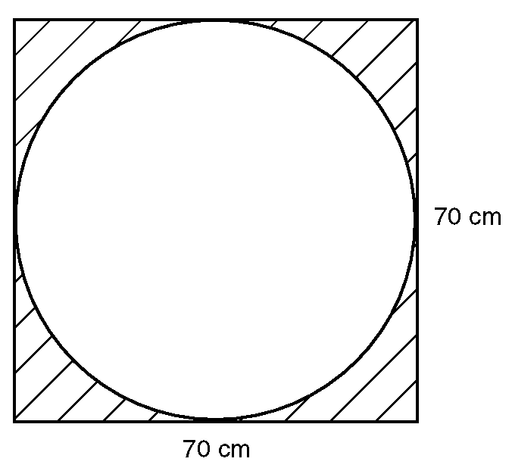

Work out the area of the shaded part of the diagram.
Give your answer correct to 3 significant figures.

5.
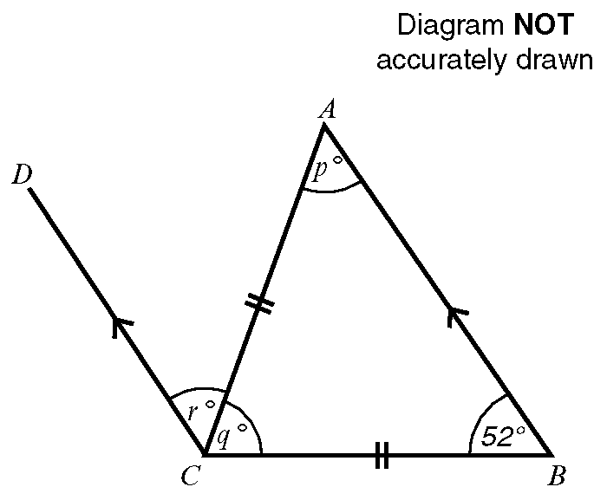
AC = BC
AB is parallel to DC
Angle ABC = 52º
a Work out the value of
i p

ii q

The angles marked pº and rº are equal.

b What geometrical name is given to this type of equal angles?

_______________________________________

Algebra

1a Write down and simplify an algebraic expression for the perimeter of this triangle.

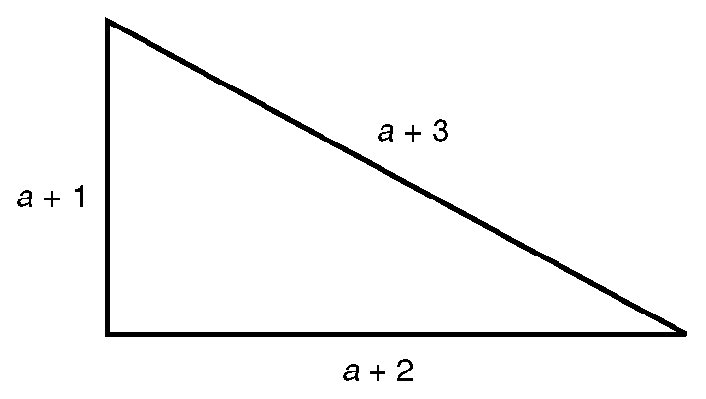

1b Write down and simplify an algebraic expression for the perimeter of this rectangle.

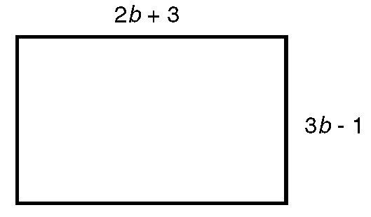

1c. The perimeter of this triangle is 31 cm.

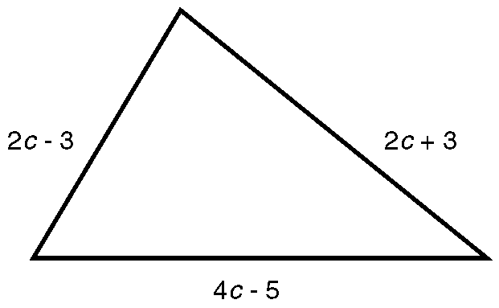

Work out the value of c.

___________________________________________

Number

Work out:
a i of £9.60,

ii 24% of 35 metres.

b Change into

i a decimal fraction,

ii a percentage.

Handling Data

1. Here are the numbers of people living in the different houses in a short road.

4, 2, 3, 4, 5, 1, 3, 2

a Work out the mean number of people per house.

b Work out the range of the number of people living in a house.

One of the houses is to be chosen at random.
c On the probability line below, mark with a letter X the probability that the house chosen will be the one with 5 people.

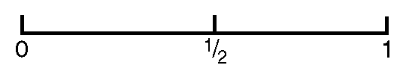
2. Hemlata measured the lengths of 12 different leaves that she collected for a Science experiment. Here are her results.

15 cm, 12 cm, 9 cm, 10 cm, 9 cm, 7 cm
14 cm, 10 cm, 8 cm, 9 cm, 12 cm, 6 cm

a For the leaves Hemlata collected work out the
i mean,

ii mode,

iii range,

iv median.

b Write down the probability that a leaf chosen at random from Hemlata's collection has a length
i equal to 10 cm,

ii less than 10 cm.

Week W: Stem & Leaf Diagrams & Box Plots

- The data gives the number of minutes waited by people to fly on the ‘London Eye’.
44, 56, 50, 52, 40, 40, 38, 44, 52, 53, 54, 38, 30, 41, 40, 51, 62, 34, 40, 47, 50, 54, 50, 57

  - Draw a stem and leaf diagram to show this data

  - Find the Median value for the data set.

